Hake with haricot beans and

salsa verde
Complexity: medium-high
Ingredients
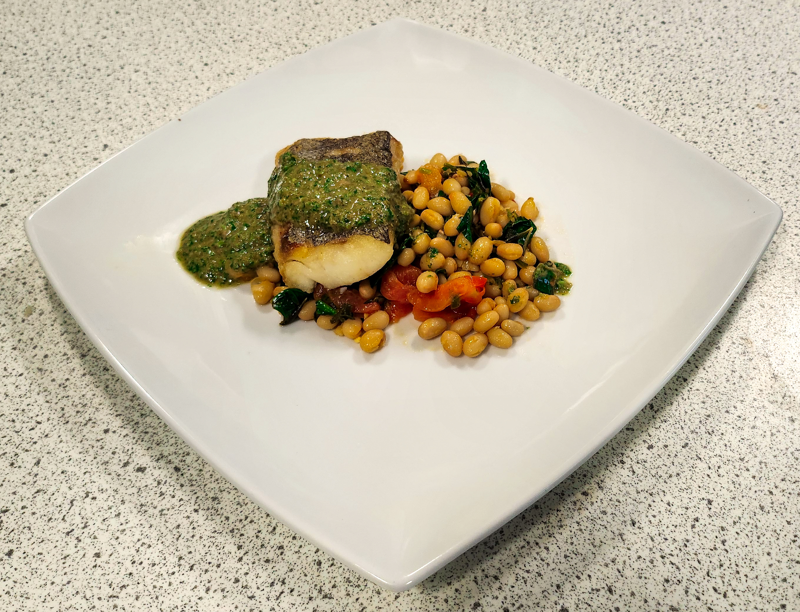
1 garlic clove
¼ red chili
½ lemon
2 handfuls of spinach
60g canned haricot beans
1 x 5ml spoon fresh or dried rosemary
1 x 5ml spoon fresh or dried thyme
1 x 5ml spoon fresh or dried sage
2 x 5ml olive oil
Bay leaf
2 or 3 baby plum tomatoes
1 hake fillet
Freshly ground pepper

Salsa verde
30g fresh parsley
30g fresh basil
30g fresh mint
30g fresh tarragon
1 garlic clove
2 x 15ml spoon capers
1 x 5ml spoon red wine vinegar
3 anchovies
1 x 5ml spoon Dijon mustard
extra virgin olive oil

Equipment
Chopping board, vegetable knife, juicer, sieve, saucepan and lid (or greaseproof/ parchment paper), mixing spoon, measuring spoons, non-stick frying pan, fish slice, baking tray, food processor or blender.

Method
- Preheat the oven to 220ºC/gas mark 8.
- Prepare the ingredients:
  - peel and chop the garlic;
  - finely dice the red chilli;
  - juice the lemon;
  - wash and roughly chop the spinach;
  - drain and rinse the beans;
  - roughly chop the fresh rosemary, thyme and sage, if using.

- Place the beans, garlic, rosemary, thyme, sage, chilli, tomatoes, bay leaf and 1 x 5ml olive oil in a saucepan and stir. Cover with a lid or a layer of parchment paper and cook gently for 10 minutes.
- Add the spinach to the hot beans and stir until it has wilted.
- Add the lemon juice and remove from the heat. Keep warm.
- Add 1 x 5ml spoon olive oil to a frying pan and cook the hake, skin side down, until the skin is crispy.
- Place the fish on a baking tray and cook in the oven until the flesh is white and opaque, approximately 5-8 minutes.
- To serve, place the hake on top of the beans and spoon over the salsa verde.

Method – salsa verde
- Roughly chop the parsley, basil, mint and tarragon.
- Peel and roughly chop the garlic.
- Drain the capers.
- Place the herbs, capers, garlic, vinegar, anchovies and Dijon mustard in a blender and pulse a few times into a coarse sauce, adding just enough oil to achieve a pouring consistency.

Top tips
- To achieve a crispy skin, make sure the fish skin is dry before frying and hold down in the pan with a fish slice for 30 seconds.
- Try pollock, pouting or gurnard instead of hake.
- Use a layer of greaseproof paper in a lightly oiled frying pan to prevent the fish sticking if your frying pans are not non-stick.

Food skills
Weigh and measure
Peel
Dice
Chop
Juice
Simmer
Fry
Bake
Blitz

This recipe was kindly donated by Food Teachers Centre, through their FISH (Fish in School Hero) programme.

