Hazard Analysis Critical Control Point (HACCP)
- Name three potential legal consequences for a food business that is found to be producing unsafe food.
- _____________________________________________________________

- _____________________________________________________________

- _____________________________________________________________

- Complete the acronym below to show what HACCP stands for.

H _______________
A _______________
C _______________
C _______________
P _______________

- Match the explanations on the right to the words that describe HACCP on the left.
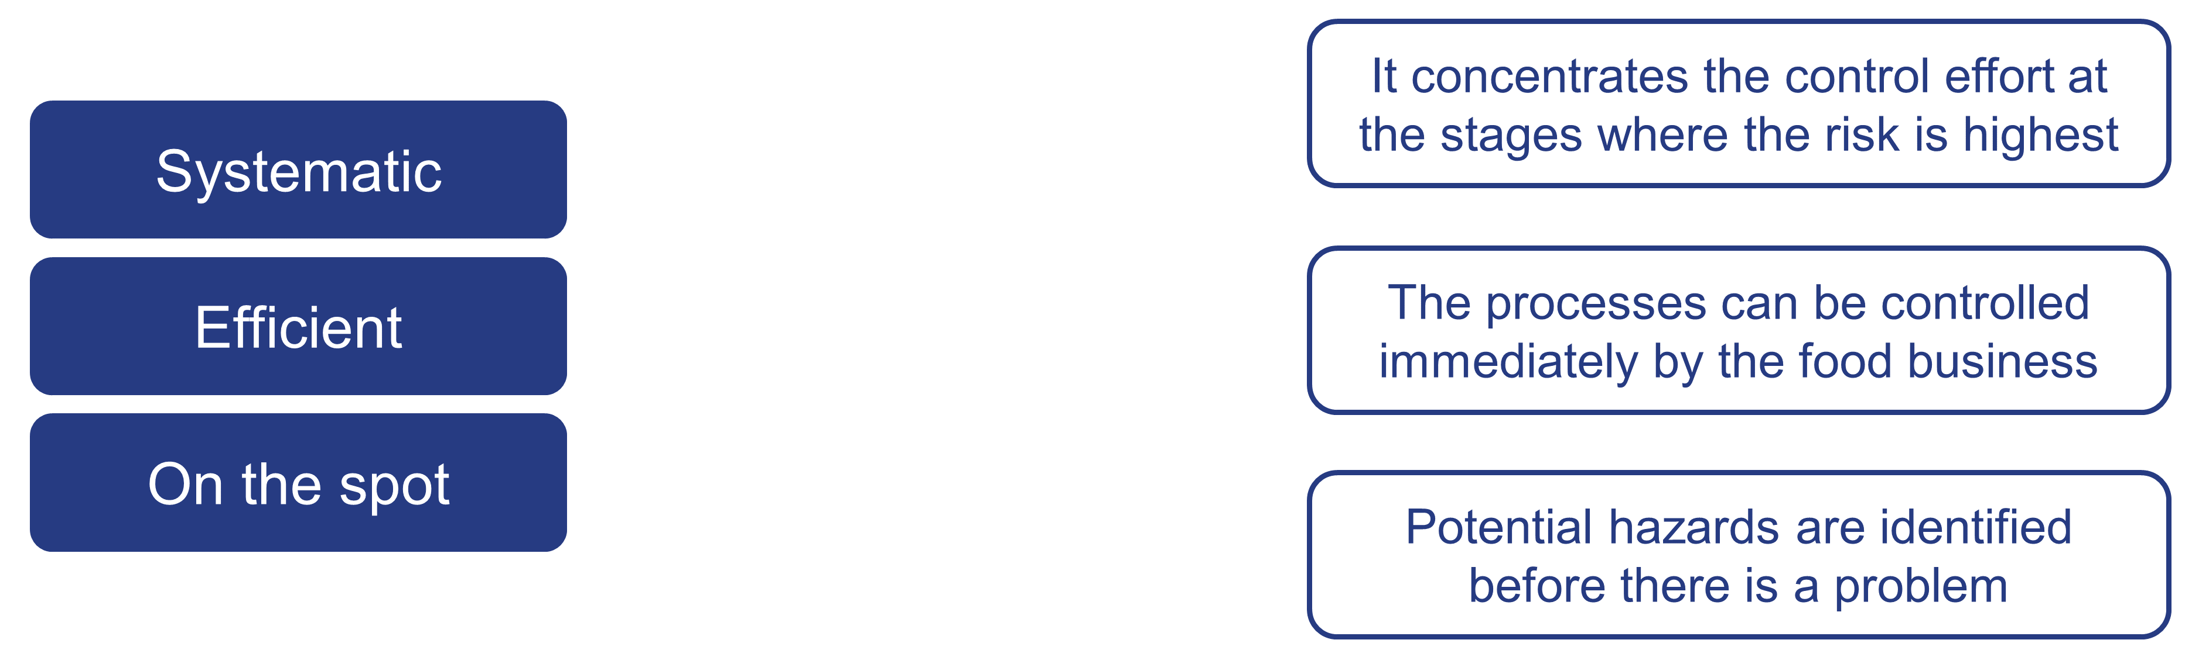

- Define the term ‘hazard’.

______________________________________________________________________

______________________________________________________________________

______________________________________________________________________

- Name three different types of hazard.

- _______________________
- _______________________
- _______________________

- Number the seven principles of HAACP in order.

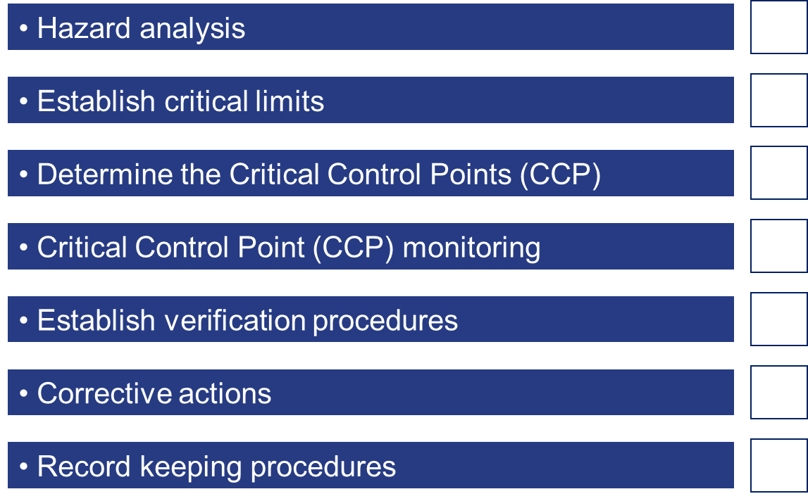

- Explain the term Critical Control Point (CCP).
______________________________________________________________________

______________________________________________________________________

______________________________________________________________________

- Explain when the design and running of a HACCP scheme should be revised.
______________________________________________________________________
______________________________________________________________________
______________________________________________________________________

- Describe each of the following principles of HACCP:

- Hazard analysis.
________________________________________________________________
________________________________________________________________
- Establish critical limits.
________________________________________________________________
________________________________________________________________
- Corrective actions.
________________________________________________________________
________________________________________________________________

- Record keeping procedures.
________________________________________________________________
________________________________________________________________

