Session 3: Brilliant baking
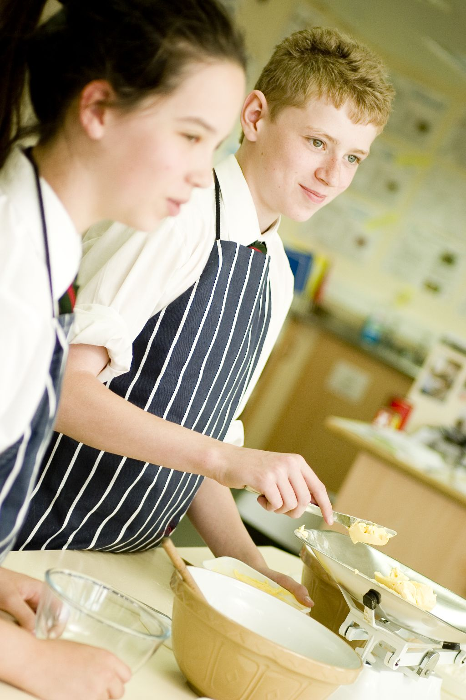
Welcome
This session introduces pupils to the safe use of the oven, as well as consolidating the use of other pieces of equipment. By now pupils will begin to feel more confident in the cooking area, understand where different equipment is stored and follow the routine of different activities. It also provides you with the opportunity to assess their practical capability, in readiness for the observation in Session 5. You could use the practical observation sheet to help.

During this session, pupils will make either fruity flapjacks or tropical granola bars. These have been chosen as they use the oven and/or the hob. These recipes also require pupils to weigh and measure their own ingredients.

There is lots of room for pupils to be creative, selecting different types of ingredients that could be combined into the dishes. You could get your pupils to use the fruit flapjacks or tropical granola bar recipe writing frames before cooking to develop their own ideas. The pupils own recipe creations could then be used in this session.

If you have an established lesson plan and/or recipe, which supports the aims and objectives of this session, feel free to use it instead. Look at the support materials provided within this session as they support this activity and may well be useful in your own lessons, e.g. worksheets, presentations.

This session can act as a stand-alone lesson, focusing on the safe use of the oven and careful weighing and measuring. Alternatively, it could be integrated into a series of lessons, e.g. exploring the different types of cereals that could be used; creating flapjack type dishes which incorporate a variety of different fruit or developing their healthy eating understanding.

Aims and objectives

Aim
For pupils to:
- become familiar with the safe use of the cooker, building their overall confidence.

Objectives
Pupils should be able to:
- use a range of basic equipment, e.g. weighing scales, saucepan;
- weigh and measure ingredients, e.g. oats, apricots, honey;
- use a hob and oven safely;
- combine ingredients thoroughly;
- make a baked dish, e.g. fruity flapjacks or tropical granola bars.

Cooking session
Two cooking session plans, based on the Licence to Cook recipes are supplied within this session.

If you have your own tried and tested fruity flapjacks or tropical granola bars recipe, feel free to use it instead. In addition, you may wish to make energy bars, gingerbread people or granola bars.

Each plan refers to aspects of healthy eating, wise food shopping and food safety and hygiene which are theme which run through each session. Suggestions can be found on page 9.

Before the cooking session
There are a number of factors that you need to consider before the cooking session. More detailed guidance is available in the Cooking session guide.

You will need to consider:
- Ingredients: who will be providing the ingredients and where will they be stored?
- Recipe: are pupils going to use a printed-out copy or follow instructions on an interactive whiteboard?
- Equipment: is all the equipment needed for the session available, clean and in good working order? Check that all the ovens have two shelves available, plus oven gloves nearby. Weighing scales should also be out for pupil use. Non-stick baking tins, or greased lined tins, need to be made available. Having lined trays means that the dish can be removed easily from the baking tin, requires less washing up, and therefore saves time.
- Aprons: do you have enough and are they clean?
- Hair: do you have ties/bands for long hair?
- Containers: will pupils be able to take away the food they cook? If so, in what?
- Waste: do you have adequate disposal facilities, including recycling or composting?
- Cooking area: is it clean and ready to use?

Differentiation and inclusion
Before this practical session, you will need to consider the age, ability, previous experience and any special requirements of your pupils. This will determine recipe selection, any advanced ingredient preparation and equipment used.

Do any of your pupils need:
- ingredients pre-measured to allow them to make best use of the time available?
- assistance with their practical work, e.g. using the hob?
- less ingredients in their recipe to make it manageable?
- ready lined baking tins or shallow foil trays?
- to follow different recipes? The fruity flapjacks recipe is easier.

Demonstration
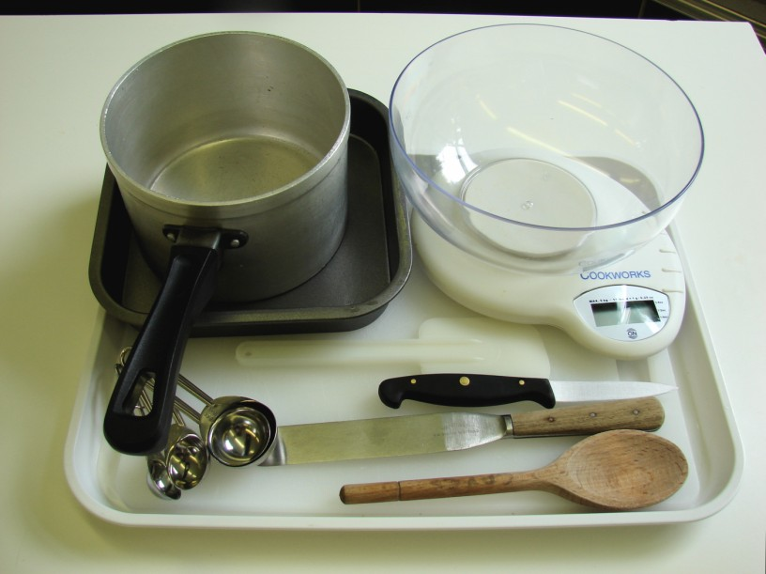
During the session you will be demonstrating the safe use of the hob and oven, as well as measuring ingredients.

Ensure that you have all the ingredients and equipment you need ready before the session, perhaps on trays for ease, for your demonstration.

Think about:
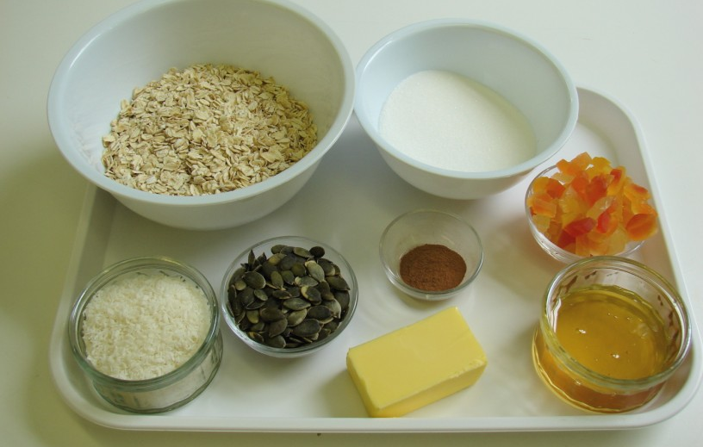
- describing the ingredients and equipment used;
- highlighting weighing and measuring accurately;
- showing how to turn on and use the hob and oven safely;
- ensuring that pupils have followed and understood the method.

Risk assessment

The two cooking session plans and recipes highlight a number of different hygiene and safety issues which need to be considered before, during and after the cooking session.

Before the cooking session, you will need to assess these risks in relation to the number of pupils being taught, as well as their experience, and consider measures that can be put into place to manage the risk. Below are examples of potential risks, along with preventative measures.

Fruity flapjacks
Potential risk | Measure | Likelihood
Ingredient past their date marks | Check all date marks before purchase and use | Low
Cuts from using a knife unsafely | Demonstrate safe use of knives and monitor pupils’ use | Med
Burn from using the hob and/or hot saucepan | Demonstrate safe use of the hob and monitor pupils’ use | Low/Med
Burn from placing and removing flapjacks in oven | Demonstrate safe use of the oven, promote the use of oven gloves and monitor pupils’ use | Low/Med

Tropical granola bars
Potential risk | Measure | Likelihood
Contamination of ingredients, such as oats, dried fruit and sugar | Check date marks and that ingredient are in sealed packets or in air-tight containers, stored in a clean, dry place | Low
Burn from using the hob and/or hot saucepan | Demonstrate safe use of the hob and monitor pupils’ use | Low/Med
Burn from placing and removing granola bars in oven | Demonstrate safe use of the oven, promote the use of oven gloves and monitor pupils’ use | Low/Med

Time
The session plans are based on a 60 minute session

If you have less time available, you will need to modify the session plan to better suit your circumstances. For example, within this session you might:
- demonstrate the safe use of the hob and oven at another time;
- teach weighing and measuring techniques before this session;
- demonstrate key aspects from the recipe, rather than every stage;
- have ingredients pre-measured;
- provide lined baking tins;
- allow pupils to work with a partner.
During the lesson
Time (mins) | Activity: fruity flapjacks | Equipment/ Resources
0 | Registration.  Explain to the pupils that they will be making fruity flapjacks. Go through the aims and objectives for the lesson. | PowerPoint Fruity flapjack recipe
5 | Gather the pupils around a demonstration area, with your tray of ingredients and equipment. Ensure that all pupils have their apron on, hair tied back and hands washed.  Briefly talk through the recipe – note your expectations, for example:  * weighing and measuring accurately;  * using the hob safely to melt the butter or soft spread;  * combining the ingredients carefully;  * placing and removing food from the oven safely, using oven gloves;  * being hygienic and safe when preparing food. | Aprons  Demonstration ingredient and equipment tray
 | Demonstration  * Show pupils how to switch on the oven. If you have electric and gas ovens, you will need to show them both types. Remind pupils that when placing and removing items from the oven they must always wear oven gloves.  * Place out the weighing scales, and using the sugar, demonstrate how to use the scales. Ensure that all the pupils can see the scales and understanding the numbering. If you have different types of scales in the room, it might be necessary to demonstrate these too.  * To demonstrate how to measure the golden syrup, pour the syrup onto the 15ml measuring spoon over the saucepan. When you have a rounded amount on the spoon, pour the syrup into the saucepan.  * Show pupils how to switch on the hob. If you have electric and gas hobs, you will need to show them both types.  * Demonstrate the butter, syrup and sugar melting together on the hob. Emphasise that the saucepan handle should be turned away from the edge. The heat should be low, ensuring that the ingredients do not burn – they should not boil. Show the pupils how to regulate the heat for the hob.  * If you have time, you may wish to show the oats and apricots being stirred into the melted butter and pushed into the baking tray. | Aprons  Demonstration ingredient and equipment tray

15  25 | Ensure that all pupils wash their hands. Allow them to start making their fruity flapjacks.  During this time, circulate the room to ensure that pupils are preparing ingredients and have preheated the oven. In this time, pupils should:  * weigh and measure their ingredients;  * chop the apricots;  * turn on the hob and melt the fat, syrup and sugar.  Check that most pupils have reached this stage. Quickly remind pupils that they should now:  * combine all the ingredients together in the saucepan, i.e. add the oats and apricots;  * spread the mixture into a non-stick (or lined) baking tin;  * place the baking tin in the oven using oven gloves. | Basic equipment  Oven gloves  Ingredients
35 | All flapjacks should be in the oven, as they take 20 minutes to bake.
50 | Give a 5 minute time warning.  Remind pupils that all washing-up should be completed, work surfaces should be clean. Their fruity flapjacks should be out of the oven. Using a palette knife, pupils should score the flapjack into bars. It is best if the flapjacks are allowed to cool before they are removed and placed into a container.  Circulate the room, ensuring that sinks are clean and equipment is put away properly.
55 | Plenary  Pose the following questions to the pupils:  * What were the main skills demonstrated today?  * Name 3 safety tips from the lesson.  * What other ingredients could be added to the basic flapjack?
60 | Finish

After the session
Check that the room is clean and tidy. Pupils should leave the room as they find it.

The fruity flapjacks will need to be stored after the lesson, due to their heat, and may need to be kept until the end of the school day. If so, ensure that each container is loosely covered and clearly labelled with the pupil’s name and group.

If the same pupils are with you for another cooking session in the next few days or week, remind them of the ingredients and/or containers they need to bring, if appropriate. You may wish to provide pupil’s with recipes or writing frames.
During the lesson
Time (mins) | Activity: tropical granola bars | Equipment/ Resources
0 | Registration.  Explain to the pupils that they will be making tropical granola bars. Go through the aims and objectives for the lesson. | PowerPoint Tropical granola bars recipe
5 | Gather the pupils around a demonstration area, with your tray of ingredients and equipment. Get pupils to put on their aprons, tie back long hair and wash their hands.  Briefly talk through the recipe – note your expectations, for example:  * weighing and measuring accurately;  * using the hob safely to melt the butter or soft spread;  * combining the ingredients carefully;  * placing and removing food from the oven safely, using oven gloves;  * being hygienic and safe when preparing food. | Aprons  Demonstration ingredient and equipment tray
 | Demonstration  * Show pupils how to switch on the oven. If you have electric and gas ovens, you will need to show them both types. Remind pupils that when placing and removing items from the oven they must always wear oven gloves.  * Place out the weighing scales, and using the sugar, demonstrate how to use the scales. Ensure that all the pupils can see the scales and understanding the numbering. If you have different types of scales in the room, it might be necessary to show these too.  * To demonstrate how to measure the honey: pour it onto the 15ml measuring spoon over the saucepan. When you have a rounded amount on the spoon, pour the honey into the saucepan.  * Show pupils how to switch on the hob. If you have electric and gas hobs, you will need to show them both types.  * Demonstrate the butter, honey and sugar melting together on the hob. Emphasise that the saucepan handle should be turned away from the edge. The heat should be low, ensuring that the ingredients do not burn – they should not boil. Show the pupils how to regulate the heat for the hob.  * If you have time, you may wish to show the oats and other ingredients being stirred into the melted butter and pushed into the baking tray. | Aprons  Demonstration ingredient and equipment tray

15 | Ensure that all pupils wash their hands. Allow them to start making their tropical granola bars.  During this time, circulate the room to ensure that pupils are preparing ingredients and have preheated the oven. In this time, pupils should:  * weigh and measure their ingredients;  * turn on the hob and melt the fat, honey and sugar.  Check that most pupils have reached this stage. Quickly remind pupils that they should now:  * combine all the ingredients together in the saucepan, i.e. add the oats, dried fruit, desiccated coconut, cinnamon and seeds;  * spread the mixture into a non-stick (or lined) baking tin;  * place the baking tin in the oven using oven gloves. | Recipe  Demonstration ingredient and equipment tray
35 | All tropical granola bars should be in the oven, as they take 20 minutes to bake.
50 | Give a 5 minute time warning.  Remind pupils that all washing-up should be completed, work surfaces should be clean. Their tropical granola bars should be out of the oven. Using a palette knife, pupils should score the granola into bars. It is best if the granola bars are allowed to cool before they are removed and placed into a container.  Circulate the room, ensuring that sinks are clean and equipment is put away properly.
55 | Plenary  Pose the following questions to the pupils:  * What were the main skills demonstrated today?  * Name 3 safety tips from the lesson.  * What other ingredients could be added to the basic granola bars?
60 | Finish

After the session
Check that the room is clean and tidy. Pupils should leave the room as they find it.

The tropical granola bars will need to be stored after the lesson, due to their heat, and may need to be kept until the end of the school day. If so, ensure that each container is loosely covered and clearly labelled with the pupil’s name and group.

If the same pupils are with you for another cooking session in the next few days or week, remind them of the ingredients and/or containers they need to bring, if appropriate. You may wish to provide pupil’s with recipes or writing frames.
Extending this activity
This session provides a great opportunity to be integrated into existing lessons or be developed into a mini-scheme of work.

For example, pupils could:
- explore different varieties of cereal based bars available for cost and ingredients used, including sensory testing;
- plan, and create new recipe ideas for cereals based bars, linking to batch-baking or mini-enterprise themes;
- evaluate their own, and class friends’ recipes, suggesting possible modifications for the future with respect to ingredient and equipment use, as well as presentation technique.

Appropriate aspects of ICT could also be integrated, including:
- recording making with a camera;
- creating a recipe plan;
- modelling recipe quantity, cost and sensory data;
- exploring the internet for different varieties of cereal bars throughout the world.

Shopping list

Fruity flapjacks

Ingredient | x 1 | x 10 | x 20
Oats | 150g | 1.5kg | 3kg
Sugar | 50g | 500g | 1kg
Butter/soft spread | 50g | 500g | 1kg
Golden syrup | 2x15ml spoons | 300ml | 600ml
Dried apricots | 75g | 750g | 1.5kg

Tropical granola bars

Ingredient | x 1 | x 10 | x 20
Butter or soft spread | 50g | 500g | 1kg
Honey | 2 x 15ml spoons | 300ml | 600ml
Sugar | 100g | 1kg | 2kg
Jumbo oats | 150g | 1.5kg | 3kg
Cinnamon | 1 x 5ml spoon | Small jar | Small jar
Pumpkin seeds | 40g | 400g | 800g
Desiccated coconut | 40g | 400g | 800g
Tropical dried fruit | 75g | 750g | 1.5kg

Equipment list

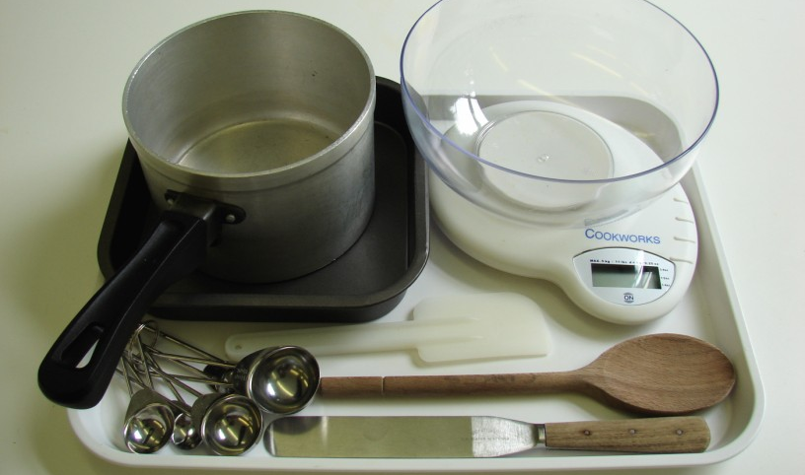
Fruity flapjacks

Chopping board
Knife
Weighing scales
Measuring spoons
Saucepan
Wooden spoon
Spatula
Non-stick baking tin
Palette knife

Tropical granola bars

Weighing scales
Measuring spoons
Saucepan
Wooden spoon
Baking tin
Spatula
Palette knife

Other
You will also need oven gloves.

Containers

If pupils take home, they will need to bring (or be provided with by the school) a suitable container, such as a plastic tub or foil container with a lid.

