
Different life stages cards



Identify three ways nutritional needs may differ at this life stage.

1.

2.

3.

How can this information be applied when planning what to cook?
Life stage – breast feeding
Life stage – weaning
Identify three ways nutritional needs may differ at this life stage.

1.

2.

3.

How can this information be applied when planning what to cook?
Cut up the cards, divide the class into groups and give each group a card. Challenge them to identify three ways nutritional needs may differ at the life stage.
Identify three ways nutritional needs may differ at this life stage.

1.

2.

3.

How can this information be applied when planning what to cook?
Life stage – pregnancy


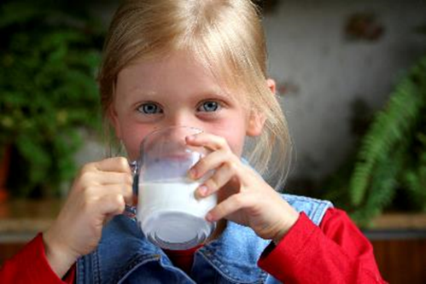
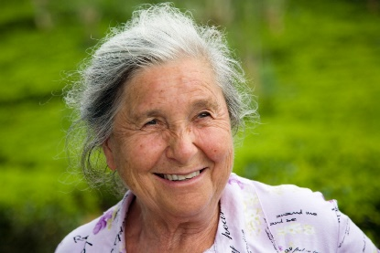
Identify three ways nutritional needs may differ when choosing locally sourced food.

1.

2.

3.

How can this information be applied when planning what to cook?
Eating local produce
Life stage – adolescence
Life stage – childhood
Life stage – later life
Identify three ways nutritional needs may differ at this life stage.

1.

2.

3.

How can this information be applied when planning what to cook?
Identify three ways nutritional needs may differ at this life stage.

1.

2.

3.

How can this information be applied when planning what to cook?
Identify three ways nutritional needs may differ at this life stage.

1.

2.

3.

How can this information be applied when planning what to cook?

