Functions of ingredients - cakes

There are four main methods for cake making:
• creaming or all in one (Victoria sponge or fairy cakes);
• whisking (Swiss roll);
• melting (ginger cake);
• rubbing in (rock cakes).

The creaming, rubbing in and melting methods can also be used to make biscuits.

Flour
- Forms the structure of the cake
- As the cake is heated, protein (gluten) in the flour coagulates and sets the framework and shape
- Dextrinisation occurs and starch converts into sugar
- On heating the sugar caramelizes resulting in a golden surface
Fat
- Adds colour and flavour
- Holds air bubbles (foam) which creates texture and volume
- Produces a short crumb or rich even texture dependent on the ratio of fat and method used
- Increases the shelf life

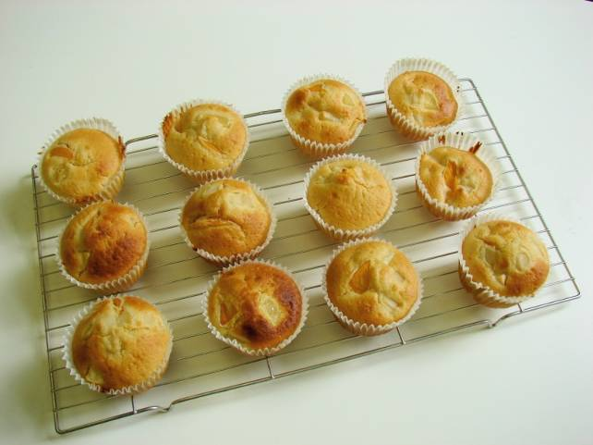
Raising agents
- Aerates the mixture increasing volume and resulting in a light texture
Sugar
- Sweetens and adds flavour
- When creamed with fat, helps to hold air in the mixture
- Caramelisation gives colour

Eggs
- Trap air when whisked into a foam
- Coagulate (set) on heating
- Emulsify holding the fat in an emulsion which keeps it stable
- Add colour, flavour and nutritional value

Problems with cakes

There are many different reasons why cakes can fail. One of the most usual is because in a creamed mixture the butter and sugar have not been sufficiently beaten together. The egg may also have been added too quickly causing the mixture to curdle. Although a cake which has curdled will rise, it will not usually rise as high as it should. It is also essential to fold in the flour in a figure-of-eight movement, using a metal spoon and not stir it in as stirring knocks out a great deal of the air which you have incorporated in the beating or whisking.

The oven temperature is also very important. If you bake a cake at too high a temperature it will not rise properly as the top forms a crust which stops the mixture underneath from expanding. Equally, if a cake is baked at too low a temperature there will not be sufficient heat to make it rise.

