Session 6: Creative crumbles

Welcome
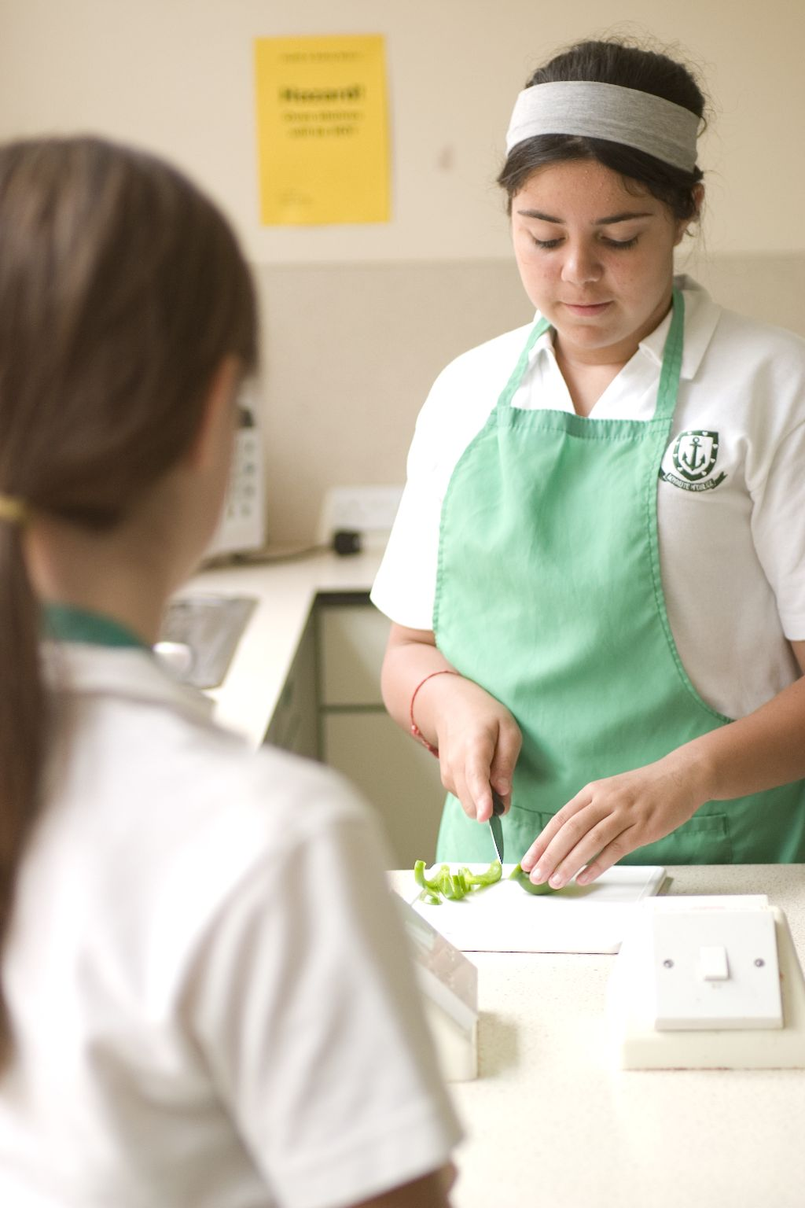
This session welcomes students back to the cooking area after they have completed their first module, i.e. sessions 1 to 5. The students should be familiar with their surroundings, understand safety aspects of using the cooker and be confident in using a range of kitchen equipment. This session aims to build on this confidence, offering students greater flexibility to be creative. It also provides you with the opportunity to assess students’ practical capability. You could use the practical observation sheet to help.

During this session, students will make either an apple and sultana or herby veggie crumble. These have been chosen as they demonstrate the rubbing in technique and the preparation of a range of bases.

There is lots of room for students to be creative, selecting different ingredients that could be combined into the dishes. You could get your students to use the apple and sultana or herby veggie crumble recipe writing frames before cooking to develop their own ideas. The students’ own recipe creations could then be used in this session.
If you have an established lesson plan and/or recipe, which supports the aims and objectives of this session, feel free to use it instead. Look at the support materials provided within this session as they support this activity and may well be useful in your own lessons, e.g. worksheets, PowerPoint presentations.

This session can act as a stand-alone lesson, focusing on the rubbing in method and the safe use of the oven. Alternatively, it could be integrated into a series of lessons, e.g. exploring the use of different ingredients for a range of toppings.

Aims and objectives

Aim
For students to:
- build their confidence through becoming more creative in selecting and handling ingredients.

Objectives
- Students should be able to:
- weigh and measure ingredients accurately;
- prepare ingredients, e.g. peeling, slicing;
- use the rubbing in technique to make a topping;
- use the oven safely;
- make a crumble dish, e.g. apple and sultana or herby veggie crumble.

Cooking session
Two cooking session plans, based on the Licence to Cook recipes, are supplied within this session.

If you have your own tried and tested crumble recipe, feel free to use it instead. You may wish to make other types of crumbles, such as rhubarb, orange and ginger or mushroom, stilton and walnut.

Each plan refers to aspects of healthy eating, wise food shopping and food safety and hygiene which are themes which run through each session.

Before the cooking session
There are a number of factors that you need to consider before the cooking session. More detailed guidance is available in the Cooking session guide.

You will need to consider:
- Ingredients: who will be providing the ingredients and where will they be stored?
- Recipe: are pupils going to use a printed-out copy or follow instructions on an interactive whiteboard?
- Equipment: is all the equipment needed for the session available, clean and in good working order? Check that all the ovens have two shelves available, plus oven gloves nearby. Weighing scales should also be out for students use. Crumbles need to be baked in oven-proof dishes – ensure that you have enough for each student, ask them to bring in one from home or have disposable foil containers available.
- Aprons: do you have enough and are they clean?
- Hair: do you have ties/hair for long hair?
- Containers: will students be able to take away the crumble they make? If so, in what?
- Waste: do you have adequate disposal facilities, including recycling or composting?
- Cooking area: is it clean and ready to use?
Differentiation and inclusion
Before this practical session, you will need to consider the age, ability, previous experience and any special requirements of your students. This will determine recipe selection, any advanced ingredient preparation and equipment used.

Do any of your students need:
- ingredients pre-measured, to allow them time to complete the recipe?
- to use pre-prepared topping or fillings?
- support preparing ingredients, e.g. coring apples?
- to use a food processor to make the crumble topping?
- to follow different recipes? The apple and sultana crumble recipe is easier than the herby veggie crumble.
- an extended range of ingredients to challenge their preparation skills?

Demonstration
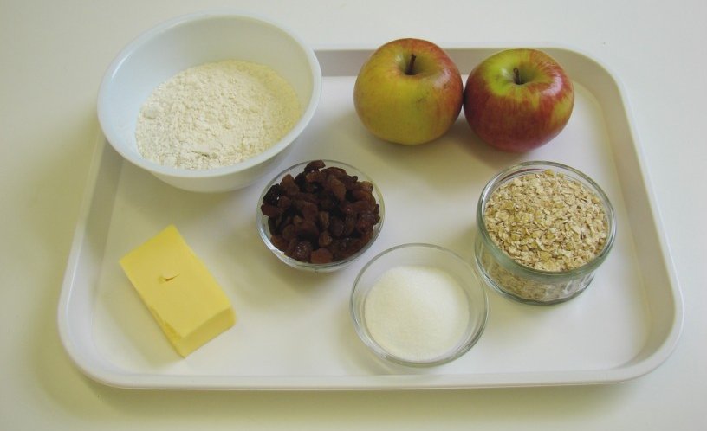
During the session you will be demonstrating the rubbing-in technique to make a crumble topping. It would also be useful to remind students of different knife techniques and safe use of the oven which they should have covered in Sessions 1 to 5.

Ensure that you have all the ingredients and equipment you need ready before the session, perhaps on trays for ease, for your demonstration.

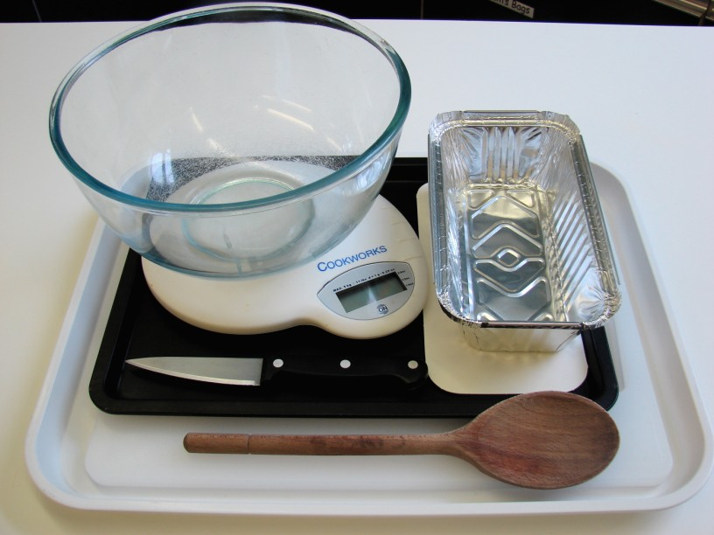
Think about:
- describing the ingredients and equipment used;
- highlighting the technique of rubbing-in;
- showing how to turn on and set the oven temperature;
- ensuring that students have followed and understood the method.

More detailed guidance is available in the Demonstrating guide.

Risk assessment

The two cooking session plans and recipes highlight a number of different hygiene and safety issues which need to be considered before, during and after the cooking session.

Before the cooking session, you will need to assess these risks in relation to the number of students being taught, as well as their experience, and consider measures that can be put into place to manage the risk. Below are examples of potential risks, along with preventative measures.

Apple and sultana crumble
Potential risk | Measure | Likelihood
Cuts from using knife unsafely when preparing the apple | Demonstrate safe use of knives and monitor students’ use | Low
Dirty hands used for rubbing-in | Wash hands thoroughly and regularly during cooking | Med
Burns from placing and removing the crumble in the oven | Demonstrate safe use of the oven, promote the use of oven gloves and monitor students’ use | Low/Med

Herby veggie crumble
Potential risk | Measure | Likelihood
Dirt or food poisoning bacteria present on raw food, causing cross contamination | Wash vegetables before use | Low
Out of date cheese used during cooking | Check date marks on food before purchase and use | Low/Med
Burn from placing and removing the crumble in the oven | Demonstrate safe use of the oven, promote the use of oven gloves and monitor students’ use | Low/Med
Dirty hands used for rubbing-in | Wash hands thoroughly and regularly during cooking | Med

Time
The session plans are based on a 60 minute session.

- If you have less time available, you will need to modify the session plan to better suit your circumstances. For example, within this session you might:
- demonstrate the safe use of the oven at another time;
- teach weighing and measuring techniques before this session;
- demonstrate key aspects from the recipe, rather than every stage;
- have ingredients pre-measured;
- instruct students bake the crumble at home;
- allow students to work with a partner.

During the lesson
Time (mins) | Activity: Apple and sultana crumble | Equipment/ Resources
0 | Registration.  Explain to the students that they will be making apple and sultana crumble. Go through the aims and objectives for the lesson. | PowerPoint Apple and sultana recipe
5 | Gather the students around a demonstration area, with your tray of ingredients and equipment. Ensure that all students have their apron on, hair tied back and hands washed.  Briefly talk through the recipe – note your expectations, for example:  * measuring accurately;  * coring and slicing the apple;  * making the crumble topping, using the rubbing-in technique;  * layering the apple slices, sultanas and crumble topping;  * pre-heating and using the oven safely;  * being hygienic and safe when preparing food. | Aprons  Demonstration ingredient and equipment tray
 | Demonstration  * Place out the chopping board, vegetable knife, mixing bowl and wooden spoon.  * Remind students about pre-heating the oven. Remind students that when placing and removing items from the oven they must always wear oven gloves.  * Demonstrate the rubbing-in method. Explain that this technique is the basis of many other recipes, e.g. scones and pastry. Place the flour and cold fat (cut into small pieces) into the bowl. The fat is cold so that it does not easily melt into your fingers and helps to form breadcrumbs. Start to rub the fat into the flour using your fingertips – thumb pressing down onto the fingers. Repeat this, moving your hands above the bowl. Shake the bowl gently, on the work surface, to bring any large pieces of fat to the surface. Rub-in until it looks like fine breadcrumbs. Clean your hands before you continue. Stir in the oats and sugar – place the bowl to one side.  * Next, demonstrate how to core an apple. Using the Bridge hold, cut the apple into quarters. Then, using the Claw grip, slice away the core. Finally, slice the apple.  * If you have time, assemble the crumble – sliced apple, covered with sultanas and then the crumble topping sprinkled over.  * If students are using foil containers for their crumbles, place these onto a baking tray before placing in the oven. | Aprons  Demonstration ingredient and equipment tray
15  30 | Ensure that all students wash their hands. Allow them to start making their apple and sultana crumble.  During this time, circulate the room to ensure that students are preparing ingredients and using the oven safely. In this time, students should:  * preheat the oven;  * measure their ingredients;  * use the rubbing-in technique to make their crumble topping;  * core and slice the apple.  At this stage most students should be ready to assemble their crumble. Check all the crumble toppings before being baked. Students should:  * assemble their crumble;  * place the crumble into the oven safely, using oven gloves. | Basic equipment  Oven gloves  Ingredients
35 | All crumbles should be baking, as they take at least 25 minutes in the oven. During this time students should be washing up, cleaning work surfaces and putting away equipment.
50 | Give a 5 minute time warning.  Remind students that all washing up should be completed, work surfaces should be clean and their apple and sultana crumbles should be out of the oven.  Circulate the room, ensuring that sinks are clean and equipment is put away properly.
55 | Plenary  Pose the following questions to the students:  * What were the main skills demonstrated today?  * Name 3 other types of fruit combinations that could be used.  * How could the crumble topping be modified to add interest?
60 | Finish

After the session
Check that the room is clean and tidy. Students should leave the room as they find it.

The apple and sultana crumble will need to be stored after the lesson, due to their heat, and may need to be kept until the end of the school day. If so, ensure that each container is loosely covered and clearly labelled with the student’s name and group.

If the same students are with you for another cooking session in the next few days or week, remind them of the ingredients and/or containers they need to bring, if appropriate. You may wish to provide students with recipes or writing frames.

During the lesson
Time (mins) |  | Activity: Herby veggie crumble | Equipment/ Resources
0 |  | Registration.  Explain to the students that they will be making herby veggie crumble. Go through the aims and objectives for the lesson. | PowerPoint Herby veggie crumble recipe
5 |  | Gather the students around a demonstration area, with your tray of ingredients and equipment. Ensure that all students have their apron on.  Briefly talk through the recipe – note your expectations, for example:  * measuring accurately;  * slicing the leek, mushrooms and red pepper;  * making the crumble topping, using the rubbing in technique;  * layering the vegetable base and crumble topping;  * pre-heating and using the oven safely;  * being hygienic and safe when preparing food. | Aprons  Demonstration ingredient and equipment tray
 |  | Demonstration  * Place out the chopping board, vegetable knife, mixing bowl and wooden spoon.  * Remind students about pre-heating the oven. Remind students that when placing and removing items from the oven they must always wear oven gloves.  * Demonstrate the rubbing-in method. Explain that this technique is the basis of many other recipes, e.g. scones and pastry. Place the flour and cold fat (cut into small pieces) into the bowl. The fat is cold so that it does not easily melt into your fingers and helps to form breadcrumbs. Start to push the fat into the flour using your fingertips – thumb pressing down onto the fingers. Repeat this, moving your hands above the bowl. Shake the bowl, on the work surface, to bring any large pieces of fat to the surface. Rub-in until it looks like fine breadcrumbs. Clean your hands before you continue. Stir in the oats, grated cheese and herbs – place this to one side.  * Next, recap how to prepare the vegetables. Use the Claw grip to slice the leeks and pepper and the Bridge hold to quarter the mushrooms. Place these into the ovenproof dish or foil tray.  * If you have time, demonstrate the assembly of the crumble – spread the canned tomatoes and herbs over the vegetables, then sprinkle over the crumble topping.  * If students are using foil containers for their crumbles, place these onto a baking tray before placing in the oven. | Aprons  Demonstration ingredient and equipment tray
15  30 | Ensure that students all wash their hands. Allow them to start making their herby veggie crumble.  During this time, circulate the room to ensure that students are preparing ingredients and using the oven safely. In this time, students should:  * preheat the oven;  * measure their ingredients;  * prepare the leek, mushrooms and red pepper;  * grate the cheese;  * make the crumble topping, using the rubbing-in technique;  At this stage most students should be ready to assemble their crumble. Check all the crumble toppings before being baked. Students should:  * assemble their crumble;  * place the crumble into the oven safely, using oven gloves. |  | Oven gloves  Ingredients  Basic equipment
35 | All crumbles should be baking, as they take at least 25 minutes in the oven. During this time students should be washing up, cleaning work surfaces and putting away equipment.
50 | Give a 5 minute time warning.  Remind students that all washing-up should be completed, work surfaces should be clean and their herby veggie crumbles should be out of the oven.  Circulate the room, ensuring that sinks are clean and equipment is put away properly.
55 | Plenary  Pose the following questions to the students:  * What were the main skills demonstrated today?  * Name 5 other types of vegetable combinations that could be used.  * How could the crumble topping be modified to add interest?
60 | Finish

After the session
Check that the room is clean and tidy. Students should leave the room as they find it.

The herby veggie crumble will need to be stored after the lesson, due to their heat, and may need to be kept until the end of the school day. If so, ensure that each container is loosely covered and clearly labelled with the student’s name and group.

If the same students are with you for another cooking session in the next few days or week, remind them of the ingredients and/or containers they need to bring, if appropriate. You may wish to provide students with recipes or writing frames.

Areas of learning

Healthy eating
- Vary the type of fruit or vegetables used in the base.
- Use wholemeal flour, instead of white, for additional fibre.
- Add other cereals, seeds or nuts to the crumble topping.

Wise food shopping
- Use frozen fruit, so you can use what you need and store the rest.
- Make more than one crumble at a time – freeze one for another time.
- Go for seasonal fruit or vegetables – they are often cheaper and at their freshest.

Food safety and hygiene
- When getting ready to cook, always wear an apron, tie back long hair, roll up long sleeves, remove any jewellery and wash your hands.
- Ensure that all fruit and vegetables are washed before use.

Extending this activity
This session provides a great opportunity to be integrated into existing lessons or be developed into a mini-scheme of work.

For example, students could:
- explore the range of crumble recipes that are traditionally made;
- plan, and create new recipe ideas for savoury crumbles, using local produce from around the UK;
- evaluate different types of ingredients for possible crumble toppings through sensory work.

Appropriate aspects of ICT could also be integrated, including:
- recording sensory data;
- creating a recipe plan or flow-chart;
- modelling the nutritional profile of the recipe;
- exploring the internet for sources of local produce or charts on seasonality.

Shopping list

Apple and sultana crumble
Ingredient | x 1 | x 10 | x 20
Plain flour | 100g | 1kg | 2kg
Butte or baking fat/block | 50g | 500g | 1kg
Oats | 50g | 500g | 1kg
Sugar | 25g | 250g | 500g
Eating apples (each) | 3 | 30 | 60
Sultanas | 50g | 500g | 1kg

Herby veggie crumble
Ingredient | x 1 | x 10 | x 20
Wholemeal flour | 100g | 1kg | 2kg
Butter or baking fat/block | 40g | 400g | 800g
Cheese | 50g | 500g | 1kg
Oats | 50g | 500g | 1kg
Leeks (small, each) | 2 | 20 | 40
Red peppers (each) | 1 | 10 | 20
Mushrooms (each) | 4 | 40 | 80
Chopped tomatoes, canned (400g) | 1 | 10 | 20
Mixed herbs | 2x5ml spoons | 20x5ml spoons | 40x5ml spoons

Equipment list

Apple and sultana bake

Weighing scales
Sieve
Mixing bowl
Chopping board
Knife

Herby veggie crumble
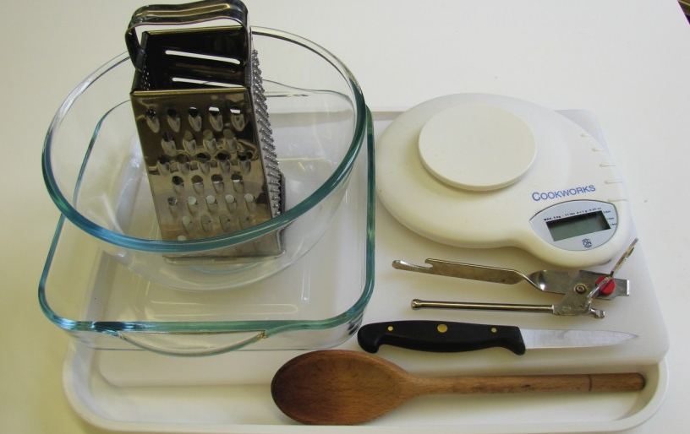
Weighing scales
Sieve
Mixing bowl
Grater
Chopping board
Knife
Can opener

Other
You may wish to have several bowls available for peelings and waste.

Containers

If students take home their crumbles, they will need to bring in an ovenproof dish or another suitable container. You may choose to use disposable foil trays for convenience.

