Swiss roll

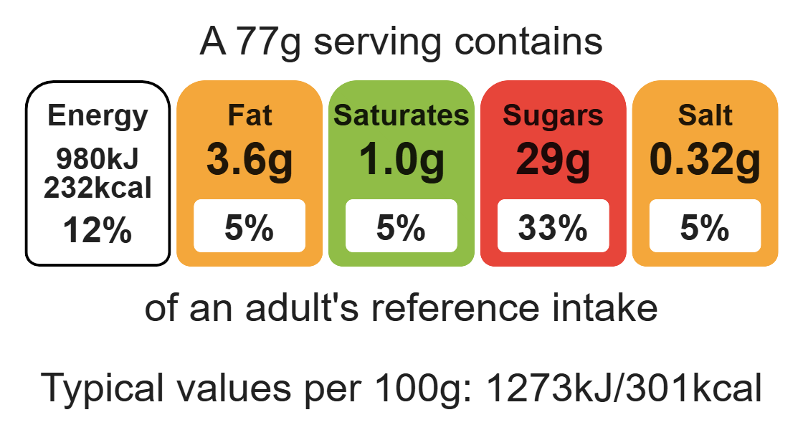

Complexity: low - medium

Ingredients (serves 4)
75g self-raising flour
3 eggs
75g caster sugar
2 x 15ml spoons jam
extra sugar for rolling up

Equipment

Weighing scales

Swiss roll tin

Greaseproof paper

Sieve

Electric hand mixer

Mixing bowl

Metal spoon

Cooling rack

Sharp knife

Method
- Preheat oven to 200ºC or gas mark 6.
- Line and grease a Swiss roll tin, 18cm x 30cm with greaseproof paper.
- Sift the flour.
- Crack the eggs into the mixing bowl. Add the sugar.
- Whisk the eggs and sugar together until thick, creamy and white.
- Gently fold in the flour, using a metal spoon, a little at a time.
- Pour the mixture into the Swiss roll tin.
- Bake for 8 – 10 minutes, until golden brown and firm to the touch. Do not overcook.
- While the Swiss roll is baking, place a piece of greaseproof paper on the worksurface and sprinkle the extra sugar on top. Warm the jam in a microwave for 10 – 15 seconds.
- When the Swiss roll is cooked, tip it onto the sugared paper. Peel off the lining paper from the cake.
- Spread the warm jam over the cake with a palette knife.
- Roll the cake, using the paper and a tea towel to help you.
- Place on a cooling rack.

Top tips
- Turn up the flavour: experiment with flavours and fillings. Substitute 25g of flour with cocoa powder to make a chocolate Swiss roll and substitute the jam with cream. Alternatively, add a few drops of lemon flavouring while whisking the egg and sugar mixture and spread with lemon curd.
- This recipe uses a ratio of 1 egg to 25g sugar to 25g flour. Therefore, you could make the recipe above with 2 eggs and 50g sugar and 50g flour.

Food skills
Weigh, measure, sift, whisk, fold, bake, microwave, spread.

