Quiche

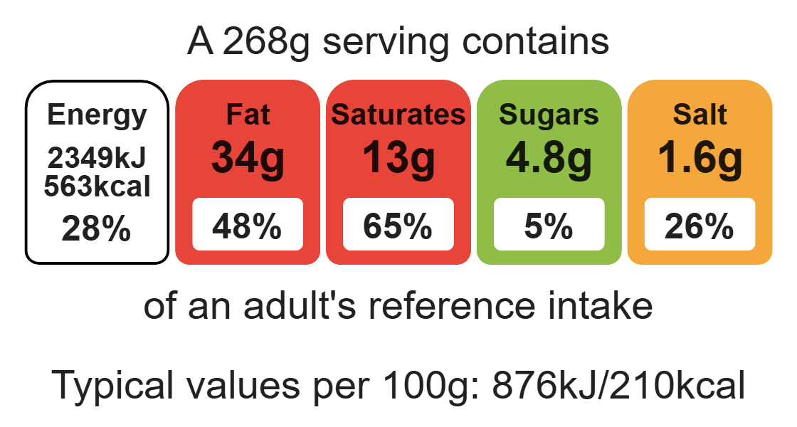
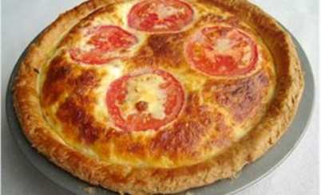

Ingredients (serves 2)

Short crust pastry
Complexity: medium

100g plain wholemeal flour

50g baking fat/block

Equipment

Flan ring

Baking tray

Sieve

Mixing bowl

Palette knife

Mixing spoon

Rolling pin

Flour dredger (optional)

Measuring spoons

Chopping board

Sharp knife

Frying pan

Fish slice

Measuring jug

Grater

Fork

2-3 x 15ml spoons water

Filling

2 eggs, large

125ml semi-skimmed milk

50g reduced-fat cheddar cheese

1 tomato

2 rashers bacon (or 3 mushrooms and 1x5ml spoon oil)

Method
1. Preheat the oven to 170ºC or gas mark 4.
2. Grease a flan ring and baking sheet or a sandwich tin.
3. Make the shortcrust pastry:
- sift the flour into a mixing bowl;
- cut the baking fat/block into cubes and add to the flour;
- rub the fat into the flour using your fingertips until the mixture resembles breadcrumbs;
- add the water a spoonful at a time and mix until the dough comes together into a soft ball.
4. Roll out the pastry, on a flowered surface, and line the flan ring/sandwich tin.
5. Prick the bottom of the pastry with a fork.
6. Prepare the quiche fillings:
- grill the bacon until crispy;
- slice the mushrooms and fry in oil for 2-3 minutes;
- grate the cheese;
- whisk the eggs and milk and add the cheese to this mixture;
- slice the tomatoes.
7. Pour the eggs, milk and cheese mixture on top of the pastry base.
8. Place the mushrooms, tomatoes and bacon on top.
9. Bake for 25-30 minutes, until golden brown and firm.

Top tips
- Reduce food waste: Use up any leftover vegetables such as peppers.
- Vary your protein: Add canned tuna for an alternative protein source.

Food skills
Weigh, measure, sift, rub-in, mix, stir and combine, roll out, grill, cut, chop, slice, dice and trim, grate, bake.

