Speedy Hungarian goulash

Ingredients
Complexity: medium-high
1 small onion
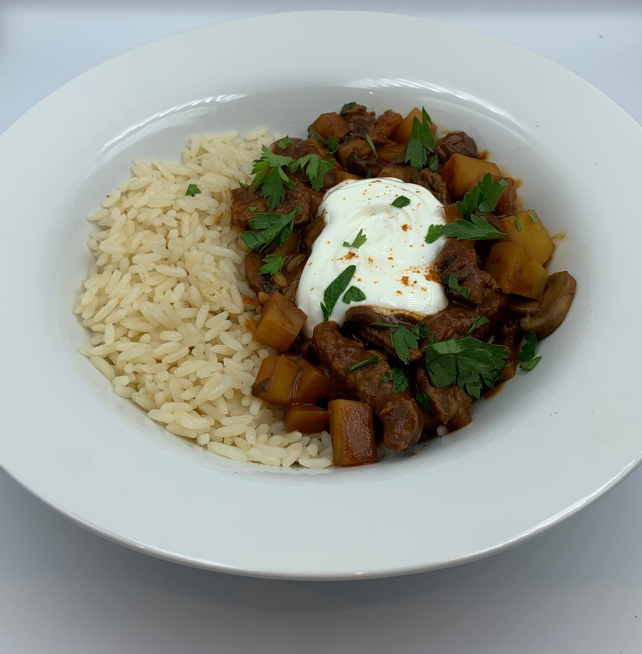
2 potatoes (approx. 250g)
50g chestnut mushrooms
Spray oil
200g stir-fry beef strips
1½ x 5ml spoon paprika
150g passata
1 reduced salt beef stock cube

Optional
A handful of fresh parsley
Reduced fat natural yogurt

Equipment
Chopping board, vegetable knife, saucepan with lid, mixing spoon, plate, measuring spoons, measuring jug.

Method
- Prepare the ingredients:
  - peel and dice the onion;
  - peel and dice the potatoes;
  - slice the mushrooms;
  - chop the parsley if using.
- Spray a saucepan with oil and fry the beef for 2 minutes, stirring occasionally. If necessary, do this in batches.
- Tip the meat onto a plate.
- Off the heat, spray with a little more oil if needed.
- Add the onion and mushrooms to the pan and fry for 2-3 minutes, until they start to colour.
- Remove from the heat and sprinkle the paprika over the onion and mushrooms and cook for 1 minute.
- Add the potatoes and passata. Crumble over the stock cube.
- Add 300ml boiling water and stir.
- Bring to the boil and then reduce to a simmer.
- Cover and cook for 20 minutes, until the potatoes are cooked.
- Add the beef and warm through, about 3-4 minutes.
- Stir in the parsley and a swirl of yogurt if using, and serve.

Top tips
- Serve the goulash with a mixed green salad. Alternatively, with brown rice, whole wheat pasta or cheese scones (known as pogácsa in Hungary).
- Try pork cubes or strips or sausages (with a high meat content) instead of beef.
- For a vegetarian dish, swap the beef for a 400g can of chickpeas or butterbeans (drained and rinsed) and add at step 11. Alternatively, use a plant-based meat alternative and increase the mushrooms to 100g.

Food skills
- Measure
- Peel
- Cut
- Slice
- Dice
- Fry
- Stir
- Boil
- Simmer

Did you know?
Goulash is considered to be Hungary’s national dish and can be traced back to the 9th Century to stews eaten by Magyar shepherds. Before setting out with their flocks, they prepared a portable stock of food by slowly cooking cut-up meats with onions and other flavourings until the liquids had been absorbed. The stew was then dried in the sun and packed into bags made of sheep’s stomachs. At mealtime, water was added to a portion of the meat to reconstitute it into a soup or stew.

The word goulash comes from the Hungarian word gulyás (pronounced almost the same only with no L) which is a word for a Hungarian herdsman or cowboy. During cattle drives the herdsmen would butcher the weaker cows that may not make the drive and make a stew or soup in a kettle over an open fire for all the gulyas. They used wild onion and caraway which grew on the Hungarian plains for flavour.

A new spice, paprika, appeared in Hungary in the 18th century and soon became an important ingredient in goulash. Christopher Columbus brought the chili peppers, locally known as paprika, to Europe from the Americas, but it took a while for it to spread across the continent. Hungarian peasants used paprika extensively as it was cheaper than imported black peppercorns and gave an appealing red colour and a hint of pungency to dishes such as goulash.

