Fibre line up cards
Print off two sets of the food cards, divide the class into two groups and ask each group to place the foods in the order they think has the least fibre to the most fibre (per 100g). Go through the answers and ask the pupils to place the foods in the correct order. Discuss what they have found out.

Did anything surprise them? How might they use this information to increase the fibre content of a recipe?

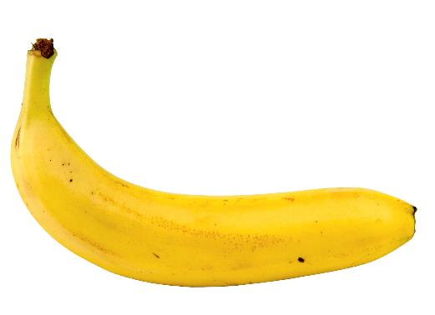
Banana
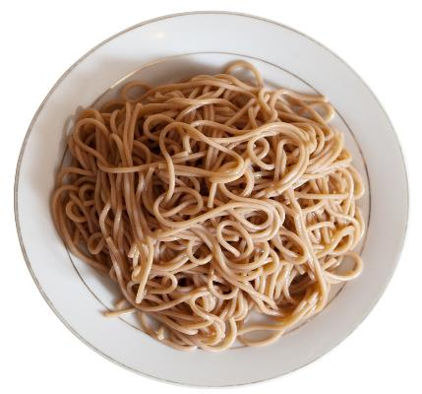

Wholemeal spaghetti - boiled

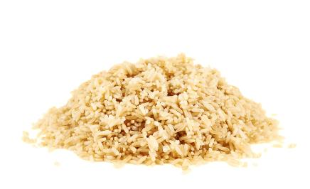

Brown rice – boiled

Brown rice - boiled

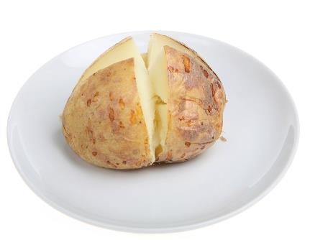

Potato with skin – baked

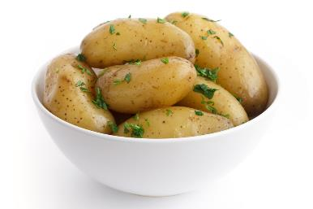
New potatoes with skin – boiled

New potatoes with skin – boiled

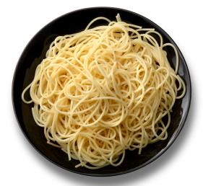

White spaghetti - boiled

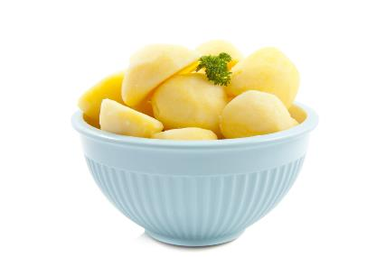
Potato, flesh only – boiled

Potatoes, flesh only - boiled

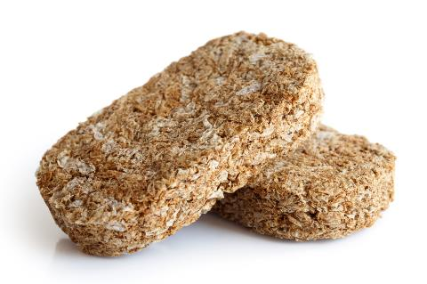

Wheat biscuit cereal

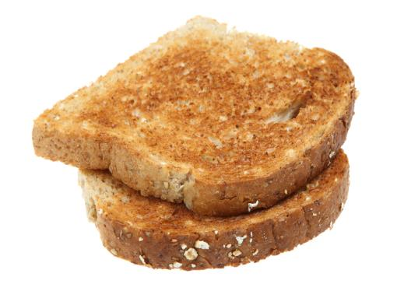

Wholemeal toast

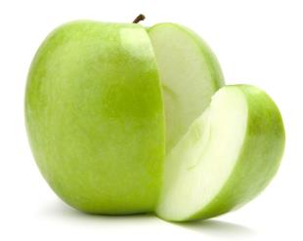

Apples

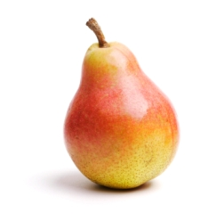

Pears

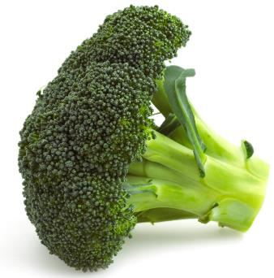

Wholemeal toast
Broccoli - boiled
Wholemeal toast

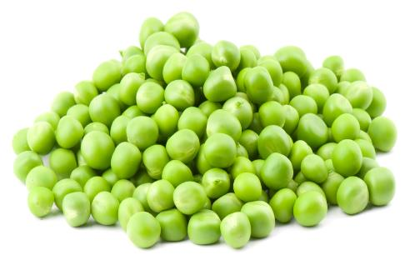

Peas - boiled

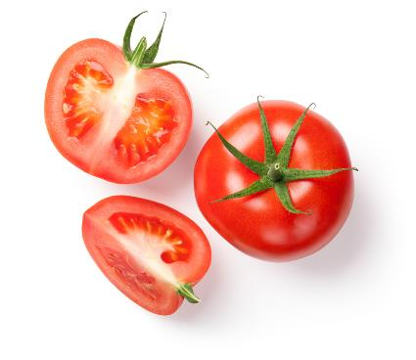

Tomatoes – average of raw, grilled, cherry and canned

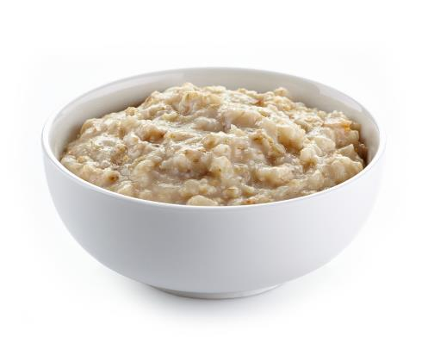
Porridge cooked with semi-skimmed milk

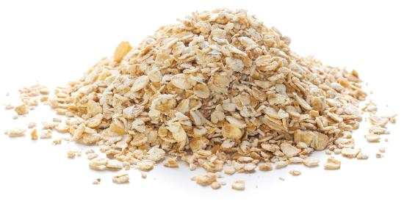

Oats

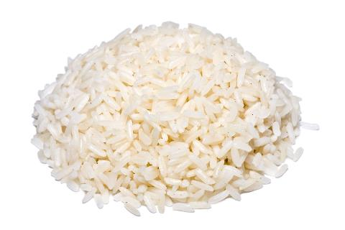

White rice - boiled

