Biotechnology and nanotechnology
- Name three food products that use microorganisms in their production.

- _________________________
- _________________________

- _________________________

- Give two reasons why industry might use biotechnology.
  - _____________________________________________________________
_____________________________________________________________
  - _____________________________________________________________
_____________________________________________________________

- Describe how fermentation is used in the production of bread.

______________________________________________________________________

______________________________________________________________________

______________________________________________________________________

- Explain the term ‘selective breeding’.

______________________________________________________________________

______________________________________________________________________
______________________________________________________________________

- Describe three potential benefits of a genetically modified plant crop.

- _____________________________________________________________
_____________________________________________________________
_____________________________________________________________

- _____________________________________________________________
_____________________________________________________________
_____________________________________________________________

- _____________________________________________________________
_____________________________________________________________
_____________________________________________________________

- Give two reasons why some individuals may be concerned about genetically modified foods.

  - _____________________________________________________________
_____________________________________________________________
  - _____________________________________________________________
_____________________________________________________________

- Define nanotechnology.

______________________________________________________________________

______________________________________________________________________

______________________________________________________________________

- Match the descriptions below to the correct step in the process of gene editing.
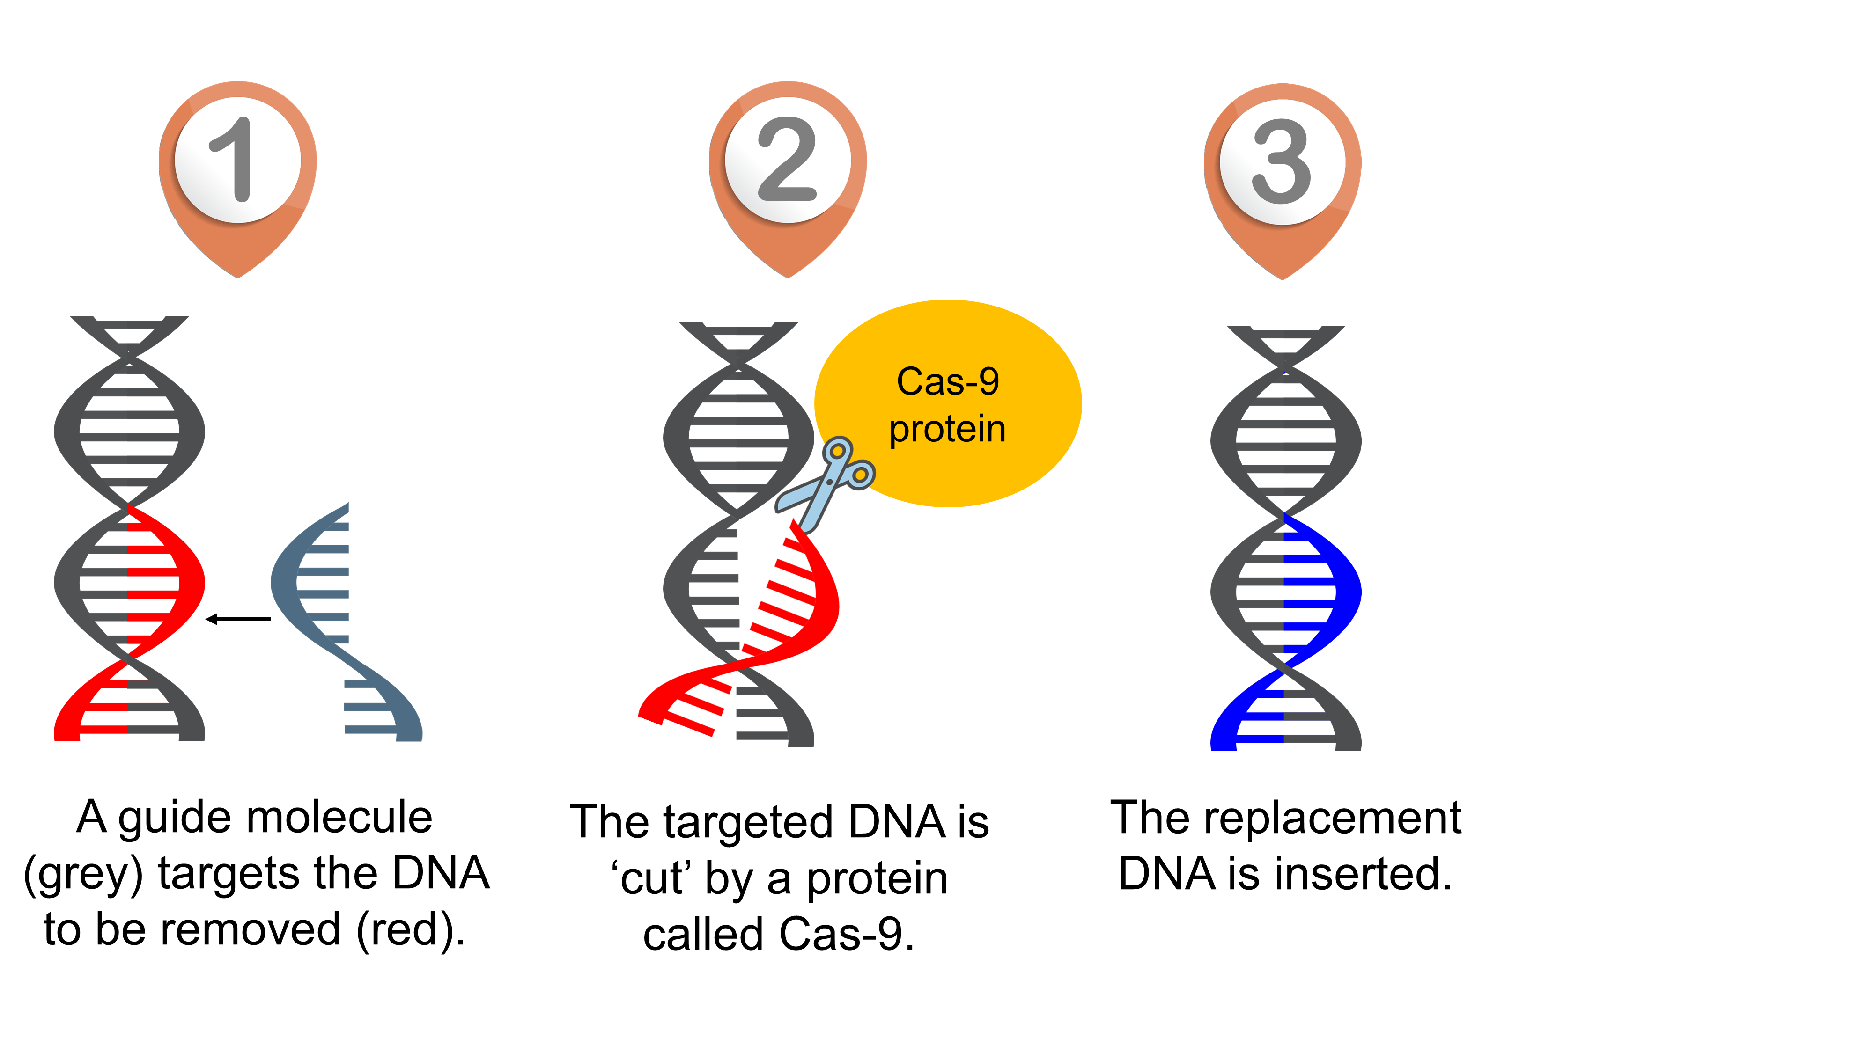


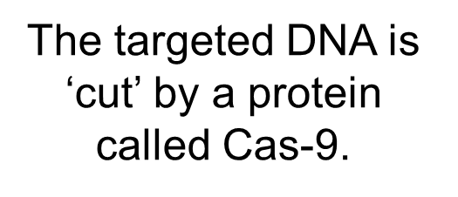
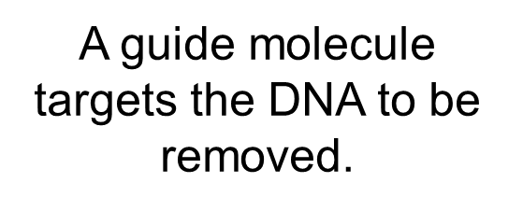

- Name the organisation that is responsible for the assessment of novel foods in the UK.

______________________________________________________________________

- Explain why foods containing nanoparticles are not widely available.
___________________________________________________________________
___________________________________________________________________
___________________________________________________________________

- Give two potential uses of nanotechnologies in food.
  - _____________________________________________________________
_____________________________________________________________
  - _____________________________________________________________
_____________________________________________________________

