Comparing food for energy

Introduction
Many food nutrition information labels show the amount of energy as kilocalories (kcal) per 100g. In theory, this is the rise in temperature of a kilogram of water caused by 100g of the food reacting completely with oxygen.

In practice, it is difficult to burn food completely and measure the rise in temperature which takes place. With simple apparatus the results are inaccurate. It is, however, possible to compare temperature changes produced by different food if the conditions for burning are exactly the same each time.

1 kilocalorie = 4.18 kilojoules (kJ)

You will need

Equipment
Small cups (for oil and fat samples)
Wicks
Cans (light meal)
Balance (readability of at least 0.1g)
Thermometer (0-100ºC)
Metal dish or saucer
Clamp stand
Spill or taper
Eye protection

Materials
Samples of fats and oils
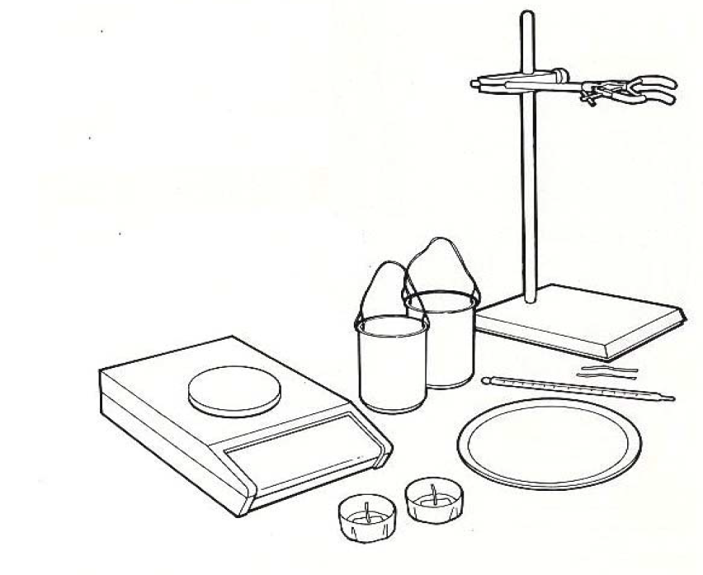


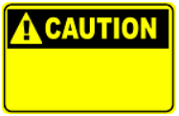
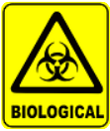
Wear eye protection.
Do not consume food in a laboratory, or any food used for experiments, because it may contaminated.

Some people are allergic or intolerant to a particular food or ingredient. Refer to the 14 allergens and check against student records before completing this experiment.

Care should be taken with lighted oil. Flames can be extinguished by covering with a damp cloth. Cups should not be moved when wicks are burning.

Method
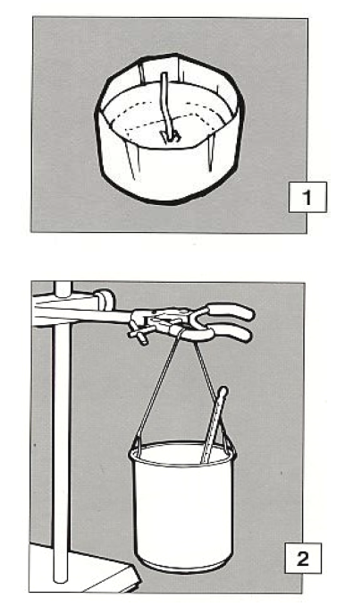

- Warm the cup or dish and half fill it with fat or oil. Set the wick in the centre and weigh the cup and its contents.

- Pour an exact amount (e.g. 100cm³) of water into the can and, together with the thermometer, set it up shown in the diagram.

- Note the temperature of the water and light the wick. Put the cup under the can as shown.

Let it burn long enough to raise the temperature by about 50ºC. Extinguish the flame and note the final temperature of the water and re-weigh the cup with its content.

- Calculate the difference between the first and final temperatures (t) of the water and between the first and final weights of the cup of oil (m).

A calorie is the energy which raises 1g of water 1ºC. so the energy per gram of oil raising the temperature of the volume of water (w) can be calculated as:

Energy = $\frac{w x t}{m}$ calories (1000cal = 1 kcal)

- Repeat steps 1-4 exactly but using different fats or oils. Compare the energy
per gram in each case.

1 kilocalorie (kcal) = 4.18 kilojoules (kJ)

