Pierogi

Ingredients
Complexity: medium- high

Filling

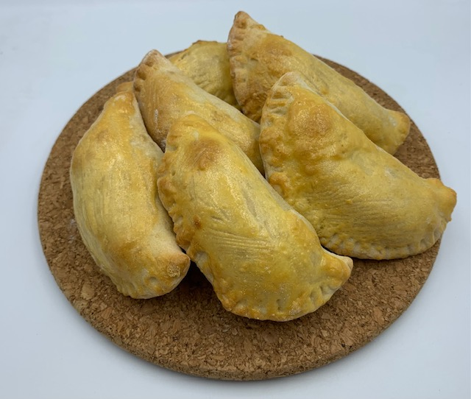
350g potatoes

1 small onion

50g cheese

Spray oil

Black pepper

Dough

60mls water

1 egg

1 ½ x 15ml spoons reduced fat sour cream or crème fraiche

180g plain flour

Optional – for garnish

Fresh chives, dill or spring onions

Reduced fat sour cream or crème fraiche

Equipment

Baking tray, greaseproof paper, vegetable peeler, vegetable knife, chopping board, grater, large saucepan and lid, small frying pan, mixing spoon, potato masher, small bowl/jug, fork, mixing bowl, flour dredger, rolling pin, large round cutter, 5ml spoon, slotted spoon, plate.

Method
- Line a large baking tray with greaseproof paper and sprinkle with flour.
- Prepare the ingredients:
- peel the potatoes and cut into small even size cubes;
- peel and finely chop the onion;
- grate the cheese;
- prepare the garnish if using – chop the herbs or thinly slice the spring onion.
- Fill a large saucepan with water. Add the potatoes, bring to the boil and cook for 12 to 15 minutes, until the potatoes are soft.
- Spray a small pan with oil and heat gently. Add the onion and cook, stirring, until just softened.
- When the potatoes are cooked, drain and return them to the saucepan. Use a potato masher to mash the potatoes until smooth.
- Add the sauteed onions, cheese and black pepper to season. Continue to mash the mixture until the potatoes are smooth and everything is well mixed.
- Leave to cool.
- Mix together the water, eggs, and sour cream in a small bowl or jug.
- Place the flour in a large bowl and make a well in the center.
- Add the egg mixture to the well. Using a fork, mix the liquid into the flour a little at a time until all the flour has been incorporated.
- Lightly flour the work surface and turn the dough out onto it. Lightly flour your hands and gently knead until the dough is soft and pliable, about 2-3 minutes.
- Let the dough rest for about 15 minutes.
- Lightly flour the work surface and rolling pin. Working with about half the dough at a time, roll the dough out to about 3mm thick. Using a large round cutter (8 or 9 cm), cut circles from the dough (the scraps can be gathered and rerolled to make more).
- Add a large 5ml spoonful of the potato filling to the centre of a dough circle.
- Pick up the dough, fold it over the filling and carefully pinch the edges of the dough closed around the filling. A fork can also be used to seal the edges.
- Place the pierogi on the prepared baking sheet.
- Repeat with the remaining dough circles and filling.
- Chill for 15 minutes, if time allows.

To cook the pierogi:

Oven cook
- Preheat the oven to 190°C, gas mark 5.
- Bake the pierogi for 16-18 minutes until golden and crisp.

Boil
- Bring a large saucepan of water to the boil.
- Drop the pierogi in a few at a time, gently stirring them so they don’t stick together.
- Cook until they begin to bob to the surface, about 4 minutes.
- Remove with a slotted spoon, transfer to a plate and repeat until all the pierogi are cooked.

Air fryer
- Place the pierogi in the basket, spray with oil and cook at 200°C for 10 minutes (fresh) or 12 minutes (frozen).

Top tips
- The potatoes should be soft enough to mash with a fork; large chunks will tear the dough and split the pierogi.
- Any leftover potato filling can be frozen to be used at another time.
- Uncooked pierogi freeze well. Place on a lined baking sheet, freeze in a single layer until solid. Transfer to an airtight container and store in the freezer for up to 3 months. Boil frozen pierogi for 10-15 minutes, until soft and tender.
- Some recipes suggest gently frying the boiled pierogi in a little butter to add colour before serving.

Food skills
- Weigh
- Measure
- Peel
- Cut
- Chop
- Grate
- Boil
- Drain
- Sauté
- Mash
- Mix, stir, combine
- Knead
- Roll out
- Cut out
- Form and shape
- Bake

Did you know?
The word ‘pierogi’ is plural in Polish, the singular is one ‘pieróg’ – pronounced pye-roog.

Polish pierogi are usually boiled in water but can also be baked or deep fried. Boiled pierogi are softer, more like ravioli, while pan-fried have a crispy exterior, similar to pan-fried dumplings. Many different fillings are used to make pierogi, these include potato and cheese, meat such as pork, beef, chicken and veal, often served with bacon and finished with a sauce.

In some regions, buckwheat or other grains or pulses like lentils are common. In autumn and winter pierogi are often eaten with braised sauerkraut and dried forest mushrooms. They are also part of the traditional Christmas Eve dinner.

In summer pierogi are also filled with fruits such as apricots, apples, berries, or cherries served with a sauce such as a lemon curd, crème anglaise, or a raspberry or strawberry coulis. At Christmas, pierogi are made with a sweet poppy seed filling.

