Cajun inspired vegetable gumbo

Ingredients
Complexity: medium-high

1 red onion
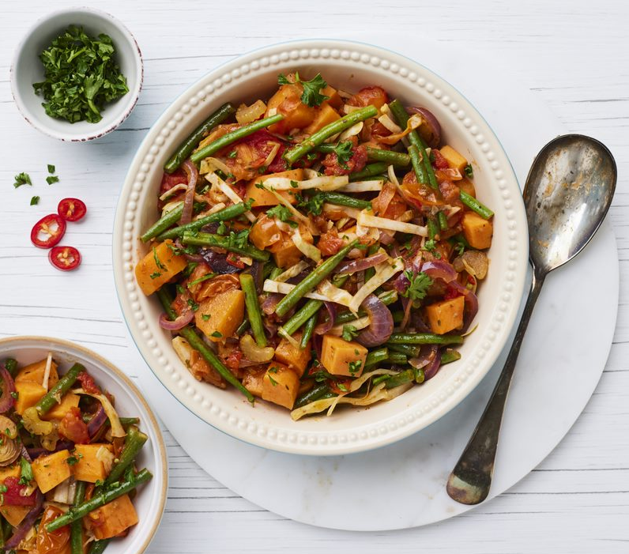

2 stalks of celery

2 fresh red chillies

2 garlic cloves

180g green beans

100g white cabbage

400g sweet potato

2 x 15ml spoons oil

2 x 5ml spoons Cajun seasoning

½ x 5ml spoon dried thyme

½ x 5ml spoon oregano

1 reduced salt vegetable stock cube

400g cherry tomatoes

Optional garnish

30g fresh parsley

Equipment

Chopping board, vegetable knife, garlic press, measuring jug, mixing spoon, measuring spoons, large saucepan/sauté pan.

Method
- Prepare the ingredients:
- peel and finely slice the onion;
- trim and finely slice the celery;
- deseed and finely chop the chillies;
- peel and crush the garlic;
- trim and halve the green beans;
- trim and finely shred the cabbage;
- peel the sweet potato and cut into 1cm dice;
- roughly chop the parsley, if using.
- Heat the oil in a large frying or sauté pan. Add the onion, celery, chili and garlic and sauté for 4-5 minutes until softened.
- Add the Cajun spice, dried thyme and oregano and stir until all the vegetables are evenly coated.
- Cook for 3-5 minutes stirring regularly.
- Make 150ml vegetable stock.
- Add the vegetable stock and tomatoes, bring to the boil. Add the cubed sweet potato. Simmer and cook for 10-13 minutes until the sweet potato is just tender.
- Stir in the green beans, cover and cook for 2-3 minutes until the beans and potatoes are tender.
- Garnish with chopped parsley.

Top tips
- Use 1 x 5ml spoon chilli powder instead of the fresh chillies.
- Add okra as an alternative or additional vegetable.
- Serve the gumbo with traditional cornbread.

Food skills
Weigh
Measure
Peel
Slice
Dice
Chop
Crush
Fry/sauté
Boil
Simmer

Did you know?
Cajun cuisine is a style of cooking developed by the Cajun–Acadians who were deported from Acadia (Canada) to Louisiana during the 18th century. After settling in the South, the French-Canadian farmers adapted their cuisine to the ingredients that were available in the region.

Their cuisine evolved to include crab, oysters, alligator, crawfish, shrimp, catfish, and redfish caught in the nearby Gulf of Mexico and waters of the bayou. Potatoes were replaced with rice, peppers took the place of carrots in stews, and new spices such as black pepper and cayenne were introduced.

Influences from the Spanish, Native Americans, and African Americans also played a key role in making Cajun cuisine as we know it today.

Popular Cajun dishes include gumbo, a soup made with filé (a spicy herb made from dried and ground sassafras leaves), okra, chicken, sausage, and sometimes shrimp, the rice-based jambalaya, boudin (pork sausage) or boudin balls (fried pork sausage), and rice and gravy.

This recipe was kindly donated by Asda Stores Limited.

