Enzymes and gels

Learning
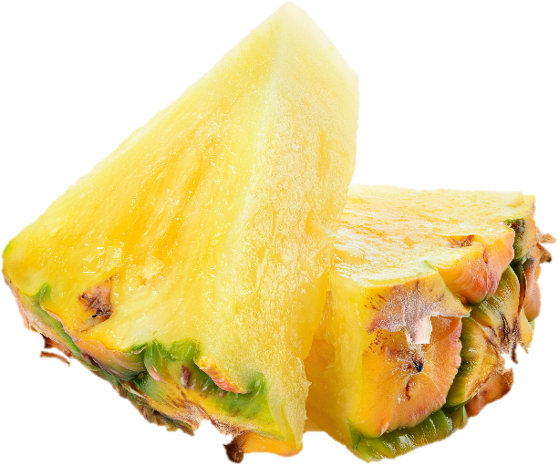
The aim of this session is to:
- demonstrate how a protein gel is formed;
- show how protease enzymes can disrupt a gel.

You will need:
- 1 x 15ml spoon gelatine powder;
- 3 x 15ml spoon cold water;
- 250ml concentrated fruit juice;
- fresh pineapple, cut into chunks;
- canned pineapple rings or chunks;
- saucepan;
- wooden spoon;
- 3 small bowls.

Instructions:
- Mix 1 x 15ml spoon of gelatine powder with 3 x 15ml spoons of cold water in a small bowl and leave for 5 minutes.
- Meanwhile, gently heat half of the fruit juice (125ml) in the saucepan. Remove from the heat when it starts to simmer.
- Add the gelatine and water from the bowl into the juice and stir until it is dissolved.
- Add the final 125ml of juice.
- Pour half of the mixture into each of the two remaining bowls.
- To one bowl, add a few pieces of fresh pineapple and to the other add a few pieces of canned pineapple.
- Place both bowls in the fridge and leave for approximately 4 hours.

Questions
Think about these questions after you have completed the experiment:
- What has happened to the two jellies when removed from the fridge? Are both set?
- What might be causing one of the jellies to not set?
- What could explain the difference between the effects of fresh pineapple and canned pineapple?

