Safe cutting techniques

The right knife?
Use the right knife for the job. A small sharp knife called a PARING KNIFE with either a straight or serrated edge is suitable for trimming and chopping fruit and vegetables.
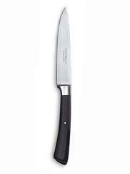
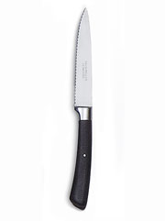

Are sharp knives dangerous?
A blunt knife is more dangerous because you have to apply much more pressure to cut through food, so if the knife slips you could cut yourself. With a sharp knife very little pressure is need to cut through food so you are less likely to slip.

The ‘BRIDGE’ cutting technique
- Cut large or awkwardly shaped items in half first. Place the flat surface on a chopping board.
- Form a bridge with the thumb and index finger of one hand and hold the item on the chopping board.
- Hold a paring knife in the other hand and position the blade under the bridge, and then cut firmly downwards.
The ‘CLAW’ cutting technique
- Place the flat side of the item you want to cut down on the chopping board.
- Shape the fingers of one hand into a claw shape, tucking the thumb inside the fingers.
- Rest the claw on the item to be sliced.
- Holding the paring knife in the other hand slice the item, moving the ‘clawed’ fingers away as the cutting progresses.

Storing knives
Consider the best and safest way for storing and looking after sharp knives.
- A knife block is a good way of checking if there any knives missing at the end of the lesson.
- The block can be stored in a locked cupboard or drawer .

The information provided in this guidance note is provided under the Open Government Licence. Terms can be found at: http://www.nationalarchives.gov.uk/doc/open-government-licence. This resource was developed for the DfE Teach Food Technology programme.

