Session 13: Celebration

Welcome
This session is about students using the creaming method to make a simple cake. It provides the opportunity to use a hand-held electric mixer, although you may wish the students to make this mixture using a wooden spoon. Weighing and measuring are important aspects of this session, as quantities need to be precise in order for the cake to have a good finish. As with other sessions, it also provides you with the opportunity to assess students' practical capability. You could use the practical observation sheet to help.

During this session, students will make either a Dutch apple cake or Marble pear tray bake. These have been chosen as they demonstrate the creaming method in cake making. In addition, students will need to line a cake tin and use the oven safely. You may wish to look at the differences between this and the all-in-one method (see session 5).

Although both of the suggested recipes are quite traditional, there is lots of room for students to be creative, selecting different ingredients that could be combined into the dishes. You could get your students to use the Dutch apple cake or Marble pear tray bake recipe writing frames before cooking to develop their own ideas. The students' own recipe creations could then be used in this session.

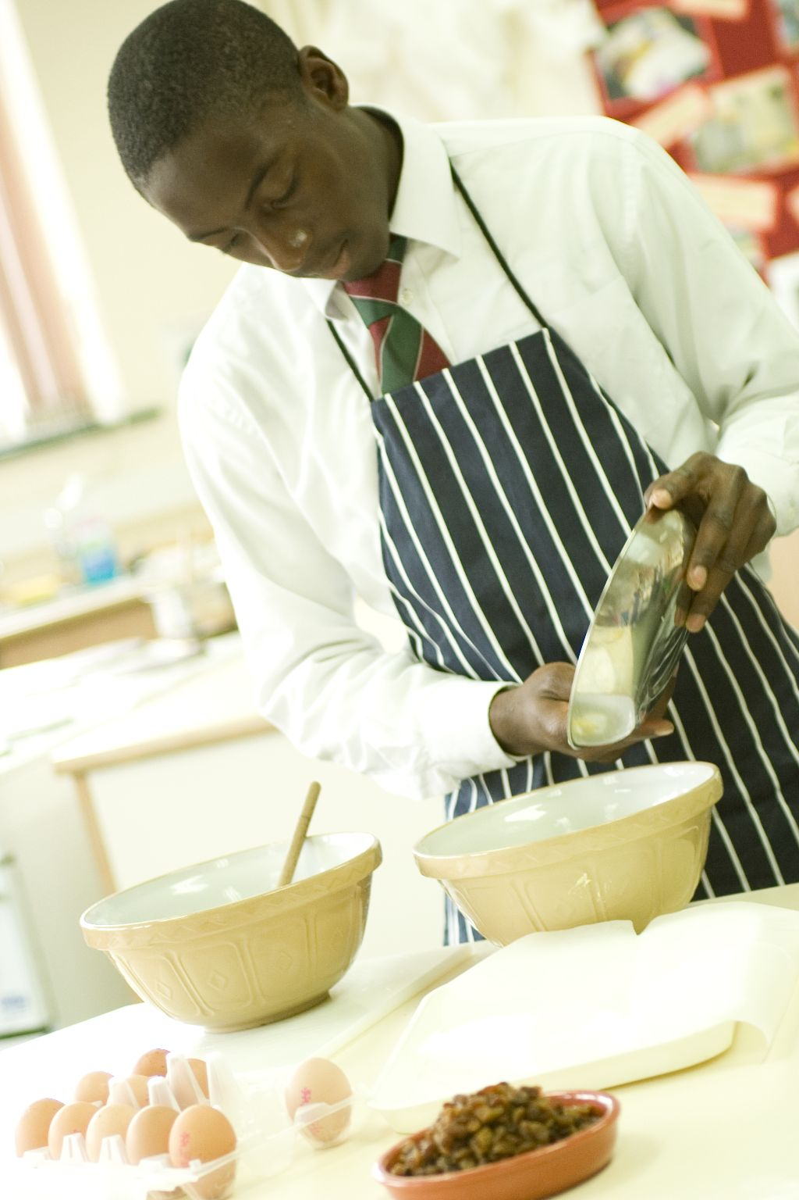
If you have an established lesson plan and/or recipe, which supports the aims and objectives of this session, feel free to use it instead. Look at the support materials provided within this session as they support this activity and may well be useful in your own lessons, e.g. worksheets, PowerPoint presentations.

This session can act as a stand-alone lesson, focusing on the creaming method and the safe use of the oven. Alternatively, it could be integrated into a series of lessons, e.g. exploring the different types of cake that use fresh or dried fruit.

Aims and objectives

Aim
For students to:
- demonstrate the use of the creaming method.

Objectives
Students should be able to:
- weigh ingredients precisely;
- make the cake mixture, using the creaming method;
- adapt a basic cake mixture
- use the oven safely;
- make a creamed cake, e.g. Dutch apple cake or Marble pear tray bake.

Cooking session
Two cooking session plans, based on the Licence to Cook recipes are supplied within this session.

If you have your own tried and tested creaming method cake recipe, feel free to use it instead. In addition, you may wish to make other types of dishes, such as coffee and walnut loaf, banana bread, fruit slice, pineapple upside down pudding, eve's pudding, carrot, lemon or coconut cake.

Each plan refers to aspects of healthy eating, wise food shopping and food safety and hygiene which are themes which run through each session.

Before the cooking session

There are a number of factors that you need to consider before the cooking session. More detailed guidance is available in the Cooking session guide.

You will need to consider:
- Ingredients: who will be providing the ingredients and where will they be stored? It may be a good idea to supply the eggs from school, or at least have some spare in case students break any on the way in. Store cupboard ingredients, like baking powder and spices, may also be provided by school.
- Recipe: are pupils going to use a printed-out copy or follow instructions on an interactive whiteboard?
- Equipment: is all the equipment needed for the session available, clean and in good working order? Check that all the ovens are in good working order and have 2 shelves. Students may find it useful to be able to use electric hand mixers. Baking tins should be available, along with oil for greasing and greaseproof paper (and scissors and a pencil) for lining. It might be easier for students to use disposable foil trays, so that there is less washing-up. Ensure that oven gloves are nearby.
- Aprons: do you have enough and are they clean?
- Hair: do you have ties/bands for long hair?
- Containers: will students be able to take away the cake they make? If so, in what?
- Waste: do you have adequate disposal facilities, including recycling or composting?
- Cooking area: is it clean and ready to use?

Differentiation and inclusion
Before this practical session, you will need to consider the age, ability, previous experience and any special requirements of your students. This will determine recipe selection, any advanced ingredient preparation and equipment used.

Do any of your students need:
- ready lined baking tins, so that their time can be spent on making the cake mixture?
- assistance with creaming fat and sugar together, perhaps using a food mixer?
- pre-prepared or weighed ingredients, e.g. sliced apple, 100g flour.
- challenging, by allowing them to adapt the recipe and include ingredients to enhance their practical skills and creativity?

Demonstration
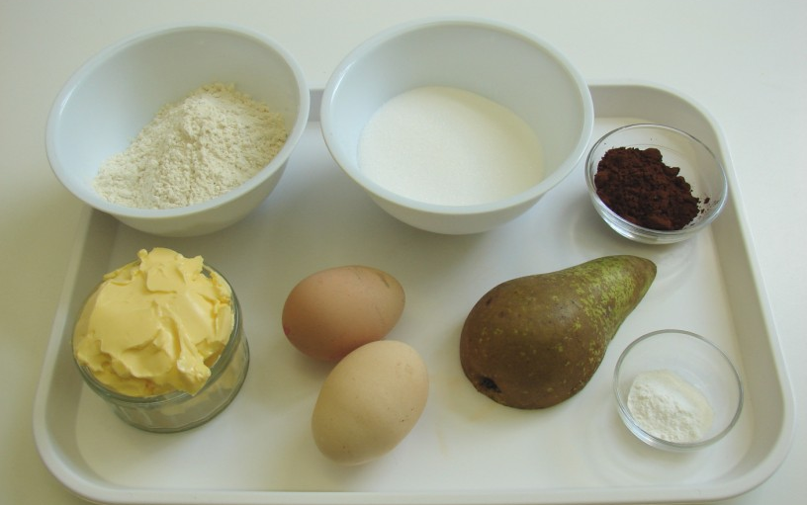
During the session you will be demonstrating how to line a baking tin and use the creaming method. If time is at a premium, go through these methods using the PowerPoint presentation - highlighting key aspects.

Ensure that you have all the ingredients and equipment you need before the session, perhaps on trays for ease, for your demonstration.
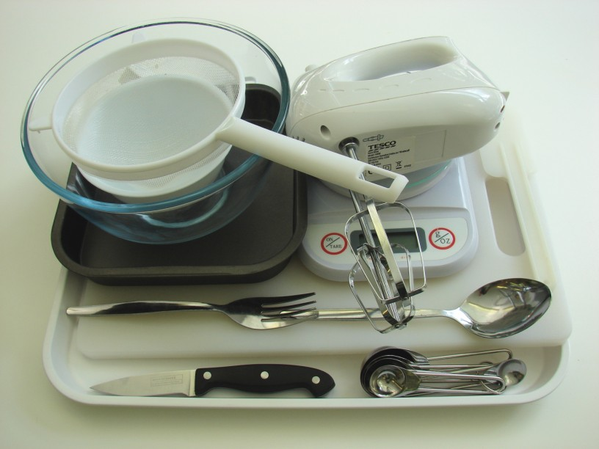
Think about:
- describing the ingredients and equipment used;
- highlighting the technique of coring an apple/pear;
- showing how to use an electric whisk;
- ensuring that students have followed and understood the method.

More detailed guidance is available in the Demonstrating guide.

Risk assessment

The two cooking session plans and recipes highlight a number of different hygiene and safety issues which need to be considered before, during and after the cooking session.

Before the cooking session, you will need to assess these risks in relation to the number of students being taught, as well as their experience, and consider measures that can be put into place to manage the risk. Below are examples of potential risks, along with preventative measures.

Marble pear tray bake
Potential risk | Measure | Likelihood
Contamination from egg shell in mixture | Crack egg into a separate bowl to check for shell, then add to main bowl | Low
Burn from placing and removing tin in oven | Demonstrate safe use of the oven, promote the use of oven gloves and monitor students’ use | Low/Med

Dutch apple cake
Potential risk | Measure | Likelihood
Contamination from egg shell in mixture | Crack egg into a separate bowl to check for shell, then add to main bowl | Low
Salmonella from raw egg | Do not eat raw egg or raw cake mixture – remind and monitor students | Low/Med
Burn from placing and removing tin in oven | Demonstrate safe use of the oven, promote the use of oven gloves and monitor students’ use | Low/Med

Time
The session plans are based on a 60 minute session.

If you have less time available, you will need to modify the session plan to better suit your circumstances. For example, within this session you might:
- demonstrate the safe use of the oven and lining a tin at another time;
- use the all-in-one method, rather than the creaming method;
- teach weighing and measuring techniques before this session;
- demonstrate key aspects from the recipe, rather than every stage;
- have baking tins pre-lined or use disposable foil trays;
- have ingredients pre-measured;
- allow students to work with a partner.

During the lesson
Time (mins) | Activity: Dutch apple cake | Equipment/ Resources
0 | Registration.  Explain to the students that they will be making Dutch apple cake. Go through the aims and objectives for the lesson. | PowerPoint  Dutch apple cake recipe
5 | Gather the students around a demonstration area, with your tray of ingredients and equipment. Ensure that all students have their apron on, hair tied back, and hands washed.  Briefly talk through the recipe – note your expectations, for example:  * lining a baking tin;  * preheating an oven;  * weighing ingredients accurately;  * using the creaming method to make the cake mixture;  * coring, slicing and arranging the apple over the cake mixture;  * using the oven safely;  * being hygienic and safe when preparing food. | Aprons  Demonstration ingredient and equipment tray
Demonstration
* Remind students about pre-heating the oven. If you have electric and gas ovens, you may need to show them both types. Remind students that when placing and removing items from the oven they must always wear oven gloves.
* Demonstrate how to line the baking tin: draw around the tin on greaseproof paper, including room for the height of each side; cut out the shape of the tin, and cut diagonally into each corner (the height of each side); grease the tin; place the greaseproof paper into the tin and push into place; lightly grease the paper - pushing into place once again.
* Place out the mixing bowl, electric hand mixer, small bowl, fork, sieve and metal spoon.
* Talk to students about using the electric hand mixer safely. Do not allow the leads to trail over water or hobs. Highlight the importance of not touching the beaters while they are moving.
* Demonstrate the creaming method. Place the butter or soft baking spread and sugar into the mixing bowl. Using the hand mixer, cream the fat and sugar together until the colour becomes very pale and it is fluffy. Crack the egg into a separate bowl – this is to check that it is fresh and that no bits of shell fall into the main mixture. Whisk the egg with a fork. Gradually add the beaten egg to the creamed mixture a little at a time to prevent the mixture from curdling. If it does curdle, simply add a little flour. Lastly, fold in the flour using a metal spoon - this is so that the air which has been incorporated into the mixture is not lost.

* If time, remind students how to core and slice the apple using the Bridge hold and Claw grip technique.
* Spread the cake mixture into the lined tin. Explain that the apple slices are arrange over the cake mixture, followed by a sprinkle of cinnamon and sugar.
* The uncooked cake mixture should not be eaten as it contains raw egg.
* Using oven gloves, place the cake tin into the hot oven carefully.
15 | Ensure that all students wash their hands. Allow them to start making their Dutch apple cake.  During this time, circulate the room to ensure that students are preparing ingredients and using the mixer and oven safely. In this time, students should:  * preheat the oven;  * line a baking tin;  * measure ingredients precisely;  * cream the sugar and fat (ideally using an electric hand mixer);  * add the egg, a little at a time;  * fold in the flour;  * core, slice and arrange the apple over the cake;  * use the oven safely to bake the cake. | Basic equipment  Ingredients  Baking tins, scissors, pencils, greaseproof paper, oil for greasing
35 | All Dutch apple cakes should be in the oven baking - they take around 20 minutes. Place the foil trays/baking tins on baking trays for extra stability.  During the remaining time students should be washing up, cleaning work surfaces and putting away equipment.
50 | Give a 5 minute time warning.  Remind students that all washing up should be completed, work surfaces should be clean and their Dutch apple cake should be on a cooling rack.  Circulate the room, ensuring that sinks are clean and equipment is put away properly.
55 | Plenary  Pose the following questions to the students:  * What were the main skills demonstrated today?  * What other fruits and spices could be used?  * How could this be adapted for a child's birthday party?
60 | Finish

After the session
Check that the room is clean and tidy. Students should leave the room as they find it.

The Dutch apple cakes will need to be stored after the lesson, due to their heat, and may need to be kept until the end of the school day. If so, ensure that each container is loosely covered and clearly labelled with the student’s name and group.

If the same students are with you for another cooking session in the next few days or week, remind them of the ingredients and/or containers they need to bring, if appropriate. You may wish to provide students with recipes or writing frames.
During the lesson
Time (mins) | Activity: Marble pear tray bake | Equipment/ Resources
0 | Registration.  Explain to the students that they will be making a Marble pear tray bake. Go through the aims and objectives for the lesson. | PowerPoint  Marble pear tray bake  Recipe
5 | Gather the students around a demonstration area, with your tray of ingredients and equipment. Ensure that all students have their apron on, hair tied back and hands washed.  Briefly talk through the recipe – note your expectations, for example:  * lining a baking tin;  * preheating an oven;  * weighing ingredients accurately;  * using the creaming method to make the cake mixture;  * coring and slicing a pear;  * using the oven safely;  * being hygienic and safe when preparing food. | Aprons  Demonstration ingredient and equipment tray
Demonstration
* Remind students about pre-heating the oven. If you have electric and gas ovens, you may need to show them both types. Remind students that when placing and removing items from the oven they must always wear oven gloves.
* Demonstrate how to line the baking tin: draw around the tin on greaseproof paper, including room for the height of each side; cut out the shape of the tin, and cut diagonally into each corner (the height of each side); grease the tin; place the greaseproof paper into the tin and push into place; lightly grease the paper - pushing into place once again.
* Place out the mixing bowl, electric hand mixer, small bowl, fork, sieve and metal spoon.
* Talk to students about using the electric hand mixer safely. Do not allow the leads to trail over water or hobs. Highlight the importance of not touching the beaters while they are moving.
* Demonstrate the creaming method. Place the butter or soft spread and sugar into the mixing bowl. Using the hand mixer, cream the fat and sugar together until the colour become very pale and it is fluffy. Crack the egg into a separate bowl – this is to check that it is fresh and that no bits of shell fall into the main mixture. Whisk the egg with a fork. Gradually add the beaten egg to the creamed mixture a little at a time to prevent the mixture from curdling. If it does curdle, simply add a little flour. Lastly, fold in the flour using a metal spoon - this is so that the air which has been incorporated into the mixture is not lost.

* If time, remind students how to core and dice the pear using the Bridge hold and Claw grip technique. (If no time, use prepared pear.) Sprinkle the pear in the baking tin.
* Spoon half the cake mixture into the lined tin in different places.
* Fold in the cocoa powder into the remaining cake mixture, then spoon this into the lined tin. Finally, swirl the two different cake mixtures together lightly to create a marble effect.
* The uncooked cake mixture should not be eaten as it contains raw egg.
* Using oven gloves, place the cake tin into the hot oven carefully.
15 | Ensure that students all wash their hands. Allow them to start making their Marble pear tray bake.  During this time, circulate the room to ensure that students are preparing ingredients and using the mixer and oven safely. In this time, students should:  * line a baking tin;  * preheat the oven;  * measure ingredients precisely;  *cream the sugar and fat (ideally using an electric mixer);  * add the egg, a little at a time;  * fold in the flour;  * core and chop the pear;  * divide the cake mixture and add cocoa to one half and pear to the other;  * use the oven safely to bake the cake. | Basic equipment  Ingredients  Baking tins, scissors, pencils, greaseproof paper, oil for greasing
35 | All Marble pear tray bakes should be in the oven baking - they around 20 minutes. The baking tins/trays can be placed on baking sheets for extra stability. During the remaining time students should be washing up, cleaning work surfaces and putting away equipment.
50 | Give a 5 minute time warning.  Remind students that all washing up should be completed, work surfaces should be clean, and their Marble pear tray bake should be served in a container.  Circulate the room, ensuring that sinks are clean, and equipment is put away properly.
55 | Plenary  Pose the following questions to the students:  * What were the main skills demonstrated today?  * What other fillings or toppings could be added?  * How could this be adapted for a celebration event?
60 | Finish

After the session
Check that the room is clean and tidy. Students should leave the room as they find it.

The Marble pear tray bakes will need to be stored after the lesson, due to their heat, and may need to be kept until the end of the school day. If so, ensure that each container is loosely covered and clearly labelled with the student’s name and group.

If the same students are with you for another cooking session in the next few days or week, remind them of the ingredients and/or containers they need to bring, if appropriate. You may wish to provide students with recipes or writing frames.
Areas of learning

Healthy eating
- Cakes can form part of a healthy balanced diet but should be eaten in moderation.
- Add fruit or vegetables to cakes.
- Go for wholemeal flour or add seeds and nuts.

Wise food shopping
- Buy economy bags of flour, which can be used in lots of recipes.
- Read egg boxes to find out how the chickens have been reared – free range eggs are usually slightly more expensive.
- Go for seasonal and/or local fruit from your area.

Food safety and hygiene
- When getting ready to cook, always wear an apron, tie back long hair, roll up long sleeves, remove any jewellery and wash your hands.
- Wash hands after handling eggs.
- Do not eat the uncooked cake mix, as it contains raw egg.

Extending this activity
This session provides a great opportunity to be integrated into existing lessons or be developed into a mini-scheme of work.

For example, students could:
- explore the different types of cake that use fruit or vegetables;
- plan and create different types of creamed cakes for different occasions and people;
- evaluate different types of cakes that are available commercially for different occasions.

Appropriate aspects of ICT could also be integrated, including:
- recording the creaming method using a digital camera;
- creating a recipe plan or flow-chart;
- modelling the cost and nutrient profile of the cake for different portion sizes;
- exploring the internet for different ingredient combinations for different tray bake ideas.

Shopping list

Marble pear tray bake
Ingredient | x 1 | x 10 | x 20
Caster sugar | 100g | 1kg | 2kg
Butter or soft baking spread | 100g | 1kg | 2kg
Self raising flour | 100g | 1kg | 2kg
Eggs (each) | 2 | 20 | 40
Baking powder | 1 x 5ml spoon | 1 tub | 1 tub
Cocoa powder | 1 x 15ml spoon | 1 tub | 1 tub
Pears (each) | 1 | 10 | 20

Dutch apple cake
Ingredient | x 1 | x 10 | x 20
Caster sugar | 100g | 1kg | 2kg
Butter or soft baking spread | 100g | 1kg | 2kg
Self raising flour | 100g | 1kg | 2kg
Eggs (each) | 2 | 20 | 40
Baking powder | 1 x 5ml spoon | 1 tub | 1 tub
Eating apple (each) | 1 | 10 | 20
Cinnamon | 1 x 5ml spoon | small jar | small jar
Brown sugar | 1 x 5ml spoon | 50g | 100g

Equipment list

Marble pear tray bake

19-20cm square baking tin, weighing scales, mixing bowl, measuring spoons, electric hand whisk, small bowl, sieve, metal spoon, knife, fork, chopping board, spatula, cooling rack.

Dutch apple cake
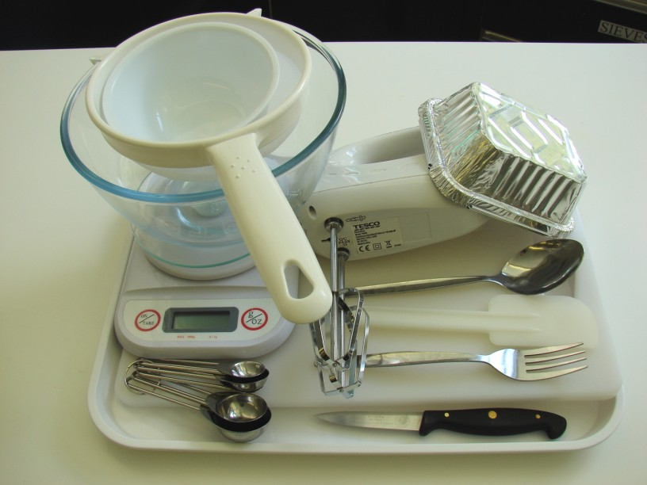
19-20cm square baking tin, electric hand whisk, mixing bowl, small bowl, sieve, metal spoon, spatula, cooling rack, measuring spoons, knife, chopping board.

Containers

If students take their dishes, they will need to bring (or be provided with by the school) a suitable container, such as a foil container with a lid.

