Scones
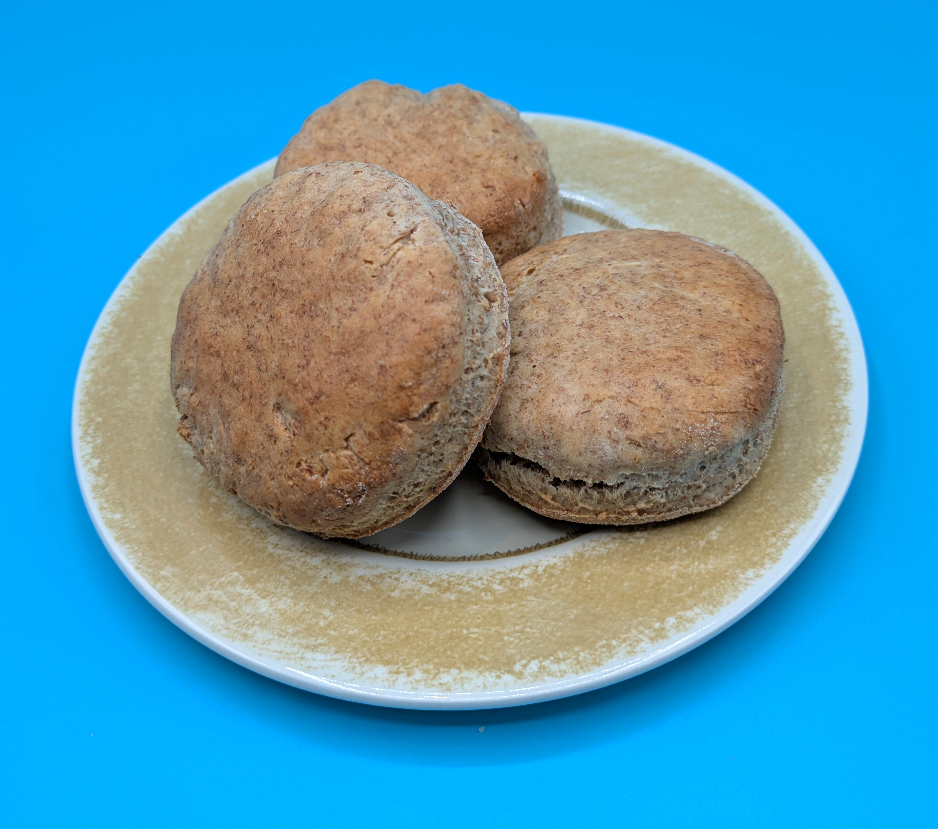
Complexity: low- medium

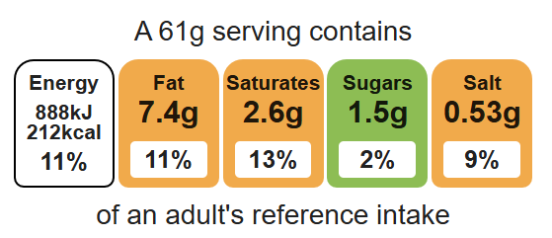

Ingredients (makes 8)

Equipment

Baking tray

Weighing scales

Sieve

Mixing bowl

Measuring jug

Palette knife

Flour dredger

Rolling pin

Scone cutter

Pastry brush

Cooling rack

125g self-raising white flour
125g self-raising wholemeal flour
40g baking fat/block
150ml semi-skimmed milk

Method
- Preheat the oven to 220ºC or gas mark 7.
- Line the baking tray.
- Sift the flour into the mixing bowl.
- Rub-in the fat into the flour using your fingertips, until it resembles breadcrumbs.
- Make a well in the middle of the flour and carefully pour in the milk gradually. Save just a little of the milk.
- Mix with the palette knife to form a ball of soft dough. If the mixture is too dry add a little extra milk.
- Place the dough on a lightly floured work surface and knead lightly.
- Flour the rolling pin. Roll out the dough to about 1.5cm deep.
- Cut-out the scones using a cutter.
- Place the scones onto the baking tray and glaze each scone with a little milk.
- Bake for 12-15 minutes, until golden brown.
- Allow to cool on a cooling rack.

Top tips
- Focus on fibre: to increase the fibre content of your scones try it with 250g self-raising wholemeal flour. Don’t forget you may need some extra liquid.
- When rubbing the spread into the flour, lift your hands to help get air into the mixture and shake the bowl to encourage large lumps to the surface.

Sweet | Savoury | Flavourings
50g blueberries  50g raisins  1 pear  1 apple | 75g reduced-fat cheese  75g Sundried tomatoes  1x spring onion  Black pepper  1x 5ml spoon pesto  1 x 15ml passata | ½ x 5ml spoon mustard powder, chives, cinnamon, ginger.
Food skills
Weigh, measure, sift, rub-in, mix, stir, combine, knead, roll out, cut out, glaze and coat, bake.

