Food treasure hunt
Walk carefully around the supermarket. Find the food on the worksheet and fill in the boxes.

Food | Question
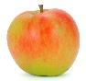  Apple | What colours can you see on this?
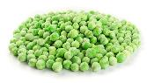  Frozen peas | Where do you find these?
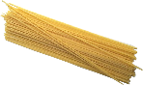  Spaghetti | Does this feel light or heavy?
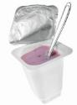  Yogurt | What other food is kept near the yogurt?
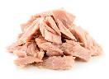  Canned tuna | How many different types of canned tuna can you see?

