Where food comes from
Farming systems
Agriculture in the UK can be grouped into the following:

• Intensive – a system of production using large amounts of labour and capital relative to land use (high input/high output);
• Extensive – a system of production using small amounts of labour and capital in relation to area of land being farmed (low input/lower output);
• Conventional – a system that may include the use of artificial and natural pesticides (to control pests, weeds and diseases), artificial fertilisers and organic manures; other techniques used may include concentrated animal feeding/rearing operations, includes both intensive and extensive approaches;
• Organic – a system where artificial fertilisers are not allowed to be used, soil fertility is built through crop rotation, and inorganic pesticide use is severely restricted. It is a form of extensive farming;
• Free-range – a system where animals, for at least part of the day, can roam freely outdoors. This may be done within a conventional or an organic system;
• Regenerative farming – a cropping system and grazing practice that, among other benefits, reverses climate change by rebuilding soil organic matter and restoring degraded soil biodiversity, resulting in both carbon capture and improving the water cycle.

Farming types in the UK
There are seven main types of farming in the UK:
- aquaculture – farming fish in fresh or sea water;
- arable – growing of crops and cereals;
- horticulture – production of flowers, fruit, vegetables or ornamental plants;
- market gardening – small scale production of fruit and vegetables;
- mixed farming – combination of arable and pastoral;
- pastoral – rearing and production of animals, including pigs, chickens, hill farming sheep, beef and dairy cattle;
- viticulture – grapes.

Farming across the UK
Some parts of the UK have excellent soil for crops, while others are used for cattle, sheep, pigs and poultry.

North West England, Wales and Scotland | Sheep and beef cattle are most suited to the land and colder temperatures.
Northern Ireland | Sheep, cattle, pigs and dairy are the largest commodity sectors.
South West England | Dairy farming is suited to this region due to the quality grass grown.
East of England | Arable crops such as wheat and barley and vegetables are grown.
South East of England and lowlands of Scotland | Grain, potatoes and sugar beet are grown along with vegetables.

Where food comes from
Food can be grown, reared or caught.

Plants are grown in an environment where light, food (soil) and water are available to help them grow and photosynthesise.

Food production and processing ensures that food is edible and safe.

Key terms
Food provenance: Knowing where food was grown, caught or raised and how it was produced.
Genetic modification: The direct manipulation of an organism's genes using biotechnology.
Hydroponics: The process of growing plants in sand, gravel, or liquid, with added nutrients but without soil.
Organic farming: A system of farming and food production. Certification is legally required to grow, process or market organic products.
Photosynthesis: The process by which green plants and some other organisms use sunlight to synthesise nutrients from carbon dioxide and water.
Seasonality: Fruit and vegetables naturally grow in cycles, and ripen during a certain season each year.

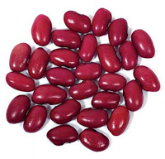
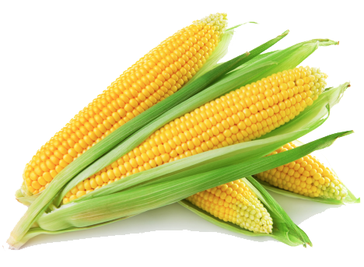
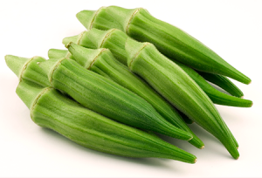
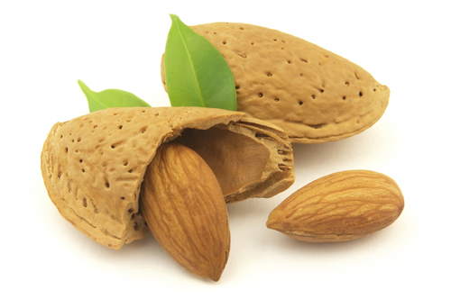
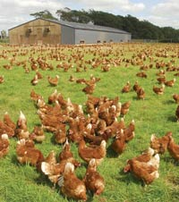
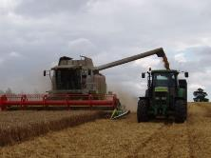
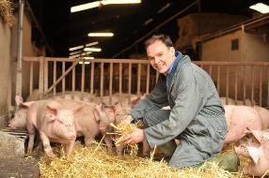
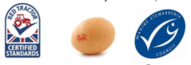
World food
There are a wide variety of ingredients and foods that are not readily available in the UK, due to the climate. These are imported from other countries.
The availability of these ingredients and foods provides consumers with a wide choice throughout the year.
The variety of ingredients and foods that are now readily available have been introduced to the UK over a long period of time.
Genetic modification and biotechnology
Genetic modification of plants and crops can help:
- improve crops resistance to pests, disease or drought;
- extend shelf life;
- improve nutrition and taste;
- produce higher yields;
- animals may be made more resistant to disease, produce less fatty meat, grow faster or be more fertile.

Tasks
- The Red Tractor food assurance scheme requires strict standards of animal welfare. List the main requirements for cows, sheep and pigs.
- Create a presentation about farming in your local area. Include how it has changed over time.
For more information, go to: https://bit.ly/398qABo
Hydroponics
Hydroponic vegetables are grown in a nutrient solution rather than soil. Tomatoes, peppers and lettuce are increasingly grown this way. Growing vegetables hydroponically enables them to be grown in a controlled environment with less chance of disease, faster growth and greater yield.

Food provenance
Food provenance is about where food is grown, caught or reared, and how it was produced.
Food certification and assurance schemes guarantee defined standards of food safety or animal welfare. There are many in the UK, including:
Historical changes
Throughout the ages, people have hunted animals and gathered plants for food, relying on what was growing locally and animals that were easy to catch. The discovery of fire meant animals and plants could be cooked to eat and taste better. The industrial revolution in the 19th century led to greater mechanisation of food production allowing for the development of new products and increased volumes of production, as well as jobs outside of the home or even the local area.
Today, other factors that affect food production include:
- domestication of animals and crops;
- preservation methods;
- development of villages and towns;
- changes of land ownership;
- transport and travel;
- war;
- religion and culture;
- famine, drought, flood, disease,
- research and development of food ingredients.

Diets have changed too and the need for cooking in the home has been reduced by the availability of processed foods.

Seasonality in the UK
Fruit and vegetables naturally grow in cycles and ripen during a certain season each year. When they are in season they are harvested.
Buying and eating food that is season means that it is fresh, has the best flavour, texture and colour, and has optimum nutritional value. Other benefits include lower cost, supporting local growers, reduced energy needed to grow and transport the ingredients and food.

