Process Manager

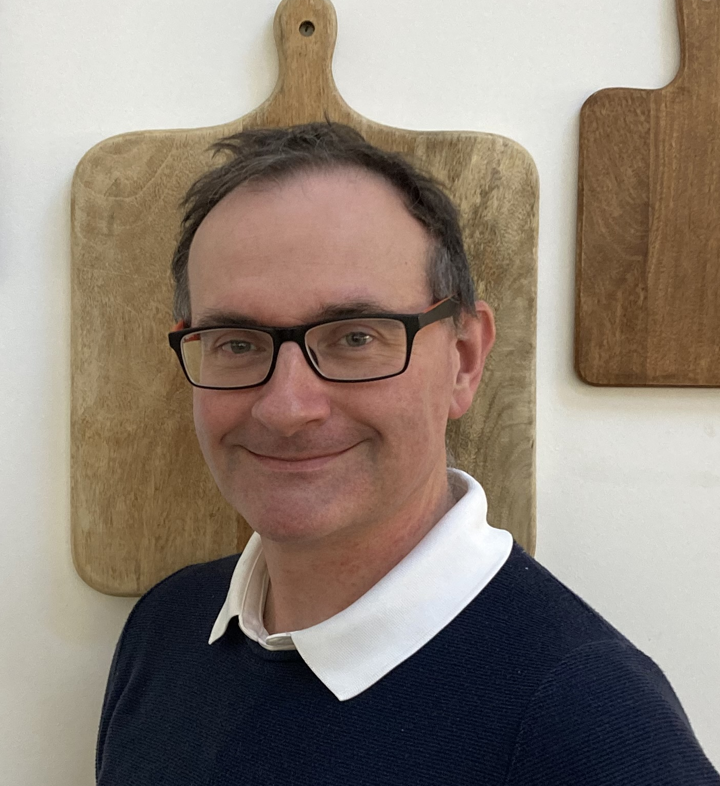
James Fox, Charlie Bigham’s

What qualifications do you have?

BSc Hons Food Science

A Levels Biology, Chemistry & Economics

GCSEs

What does your job involve?
Managing the development process of new dishes and existing dishes, ensuring the highest quality standards built into the recipes are maintained during manufacturing. With processes and procedures that are developed, tested and put in place to maintain the quality we require. Ensuring key stakeholders are kept informed and taste the food as we trial and prepare for launch. Managing a high performing team of Technologists, who constantly look to improve what we do and how we make our food. I also work on installation and commissioning of new cooking equipment, working with the suppliers to ensure everything is installed safely and to the required times to ensure a smooth project delivery. In addition, I am heavily involved in the artwork sign off process to ensure all the information on our packaging is accurate and clear for our consumers.

What, or who, inspired you to take your chosen career pathway?
My mum, who was always trying new food ideas, recipes and ways of cooking when I was a teenager. I always loved trying the new meal ideas and helping out in the kitchen. Also, a good friend who had completed her Food Technology degree gave me some great pointers on what to aim for as a career in such a dynamic and fast changing industry.

What route did you take from leaving school to your current job?
After leaving school I went to the University of Humberside to study my Food Science degree, which was not only a great learning experience in itself, it was a practical based course encapsulating all aspects of food: science, technology, nutrition, microbiology and analysis. The course had a year placement, which I was lucky to take with one company for the full twelve months, not only did I earn some money, which as a student was good, it gave me a great insight into a food business and how it operated. And it was here that I was bitten by the product development bug, seeing an idea become a reality is such a great feeling.

After graduation I worked for Rank Hovis McDougall, first in the catering foods supply side of the business, working on a diverse range of meals from chilled airline foods, frozen desserts, to bakery mixes. Followed by a move to Hovis Bakeries, working initially in the Test Bakery before moving to trialling new recipes on large scale plant bakeries across the country. It was here I first became exposed to commissioning new equipment. Working with the equipment manufacturers as they installed new kit, seeing what happens on that side of a project is such a great insight.

Followed by my final move to Charlie Bigham's, where I can use the full range of my skills: managing the development process, commissioning new equipment and seeing our new dishes launched into the marketplace. Transferring dishes from our London Kitchen to the new purpose-built Kitchen here in Somerset and leading the development process has been such a rewarding experience.

What is the key knowledge, skills and experience needed for your job?
Flexibility, being able to manage multiple projects at the same time. Attention to detail and above all else a passion for food.

What is the best thing about your job?
Being involved in great food and a great business. Seeing new dishes transform from an idea into reality.

What questions are you often asked about your job?
Do we put prawns in our fish pie? Which we never do. Or, Are you a chef? I have to explain that I don’t make the dishes. Rather I ensure the quality of our food is the best it ever can be and keeping the consumer at the heart of what we do.

What advice would you offer to someone interested in doing what you do?
Seek out opportunities to learn, every new experience will give you an amazing insight into a new approach. Always have a passion for food, it doesn’t have to be Michelin star rated, just good food, cooked with care and attention, and enjoyed. This is what keeps our business and industry going.

