Energy expenditure in physical activity
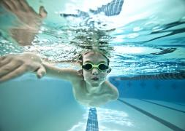

Child (12 years old), 39kg – all for 1 hour of activity

Individual sports

Boxing – 499 kcals

Fast swimming – 390 kcals (234 kcals if slow)

Gymnastics – 148 kcals

Karate – 402 kcals

Skateboarding – 195 kcals

Dancing


Fast dancing – 304 kcals

Running

Fast (10mph) – 566 kcals

Medium (7.5mph) – 449 kcals

Slow (5mph) – 324 kcals

Jogging – 273 kcals

Walking

Walking dog – 117 calories

Medium walking (3-5mph) – 168 calories

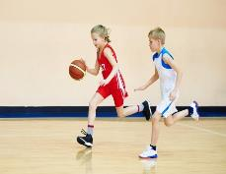
Team sports

Badminton (social) – 215 kcals (273 kcals if competitive)

Basketball – 312 kcals

Cricket – 187 kcals

Doubles tennis (social) – 178 kcals (234 kcals competitive)

Hockey – 304 kcals

Football (social) – 273 kcals (390 kcals if competitive)

Singles tennis (social) – 285 kcals (312 kcals if competitive)

Wheelchair basketball – 304 calories
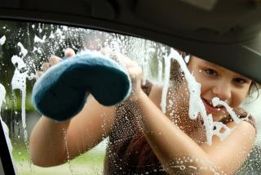

Cycling

Hard (14-16mph) – 390 kcals

Medium (12-14mph) – 312 kcals

Light (<10mph) – 226 kcals

Exercise bike

Hard – 429 kcals

Medium – 273 kcals

Light – 187 kcals

Housework
Cleaning carpets and floors – 129 kcals
Washing the car – 137 kcals

Adult (30 years), 63kg – all for 1 hour of activity

Individual sports

Boxing – 806 kcals

Fast swimming – 630 kcals (390 kcals if slow)

Golf – 302 kcals

Karate – 649 kcals

Gymnastics – 329 kcals

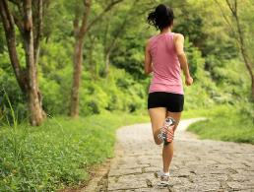
Gym

Light weight lifting – 221 kcals (378 kcals if hard)

Circuit training – 504 kcals

Medium rowing machine – 441 kcals (536 kcals hard)

Pilates – 189 kcals

Dancing

Fast dancing – 491 kcals

Running

Fast (10mph) – 914 kcals

Medium (7.5mph) – 725 kcals

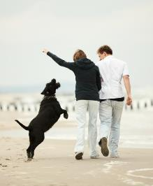
Slow (5mph) – 523 kcals

Walking

Walking dog – 189 calories

Medium walking (3-5mph) – 271 calories

Team sports

Badminton (social) – 347 kcals (441 kcals if competitive)

Basketball – 504 kcals

Cricket – 302 kcals

Doubles tennis (social) – 284 kcals (378 kcals competitive)

Hockey – 491 kcals

Football (social) – 441 kcals (630 kcals if competitive)

Singles tennis (social) – 460 kcals (504 kcals if competitive)

Wheelchair basketball – 491 calories

Cycling

Hard (14-16mph) – 630 kcals

Medium (12-14mph) – 504 kcals

Light (<10mph) – 365 kcals
This information has been taken from:
- https://bnf.nice.org.uk/about/approximate-conversions-and-units.html
- https://www.bhf.org.uk/informationsupport/support/healthy-living/staying-active/exercise-calorie-calculator

Exercise bike

Hard – 693 kcals

Medium – 441 kcals

Light – 302 kcals

Housework
Cleaning carpets and floors – 208 kcals
Washing the car – 221 kcals

