Pizza toast

- Name 5 different bases that could be used for a pizza.

- Suggest 4 different pizza toast creations, listing the toppings for each, for a youth club café.

- How could pizza toast be made healthier?
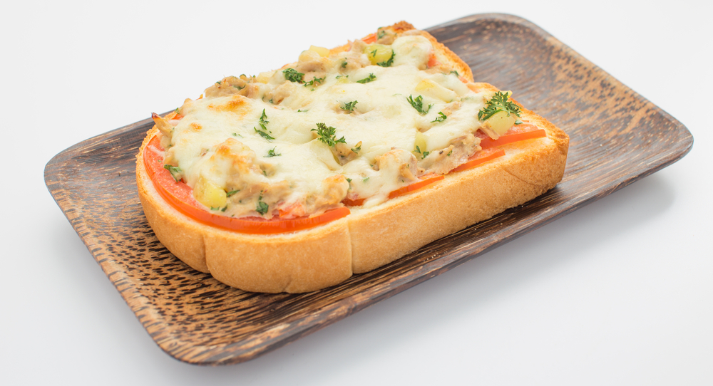

- What would be your top tips for using a hot grill?

