What would you do if you felt like you wanted to sneeze while you were cooking?

Put down any food or equipment. Move away from the cooking area to sneeze.
Blow your nose and wash your hands.
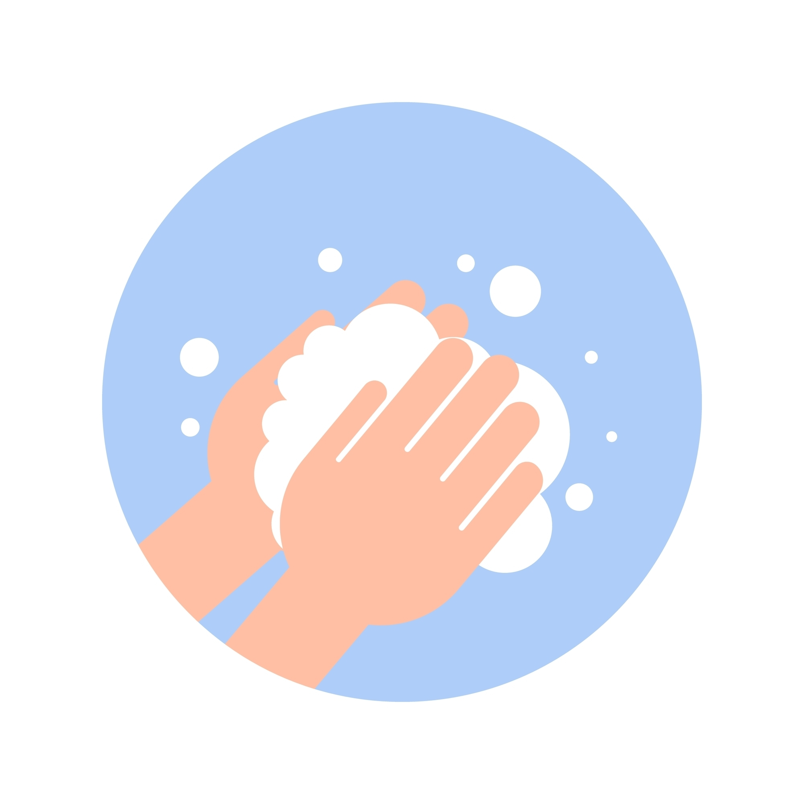
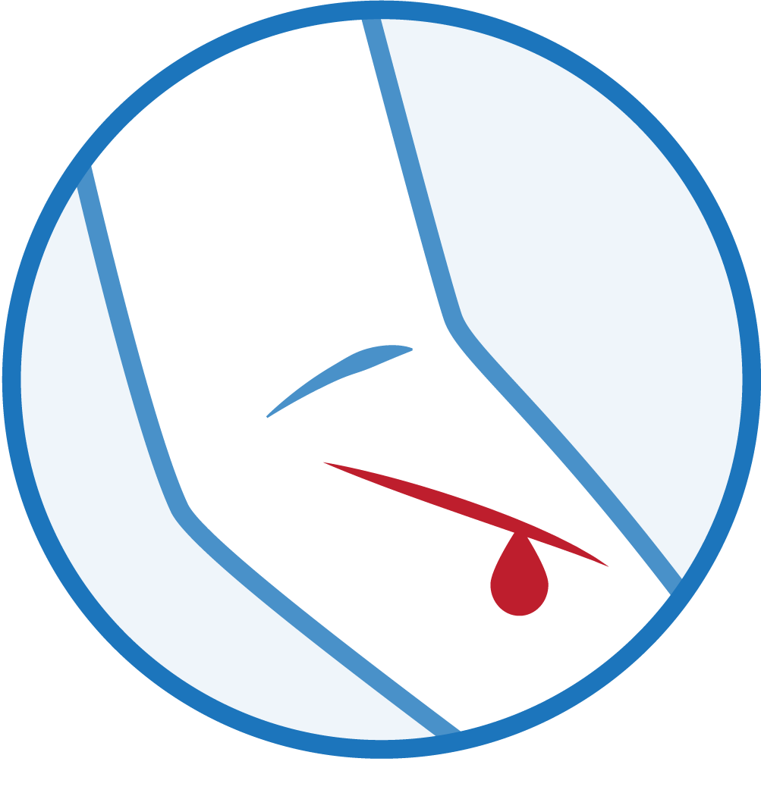
What would you do if you cut yourself during a cooking lesson?

Move away from the cooking area and tell the teacher straight away. An adult will need to treat the cut. If it is not too bad, you may be able to carry on with your cooking as long as you wear a plaster and plastic glove. If it is a bad cut, you will have to stop cooking. An adult will need to take away the equipment you were using and wash it thoroughly. The food you were working with when you cut yourself will have to be thrown away.
What would you do if you needed to go to the toilet while you were cooking?

Take off your apron and leave it in the classroom. Go to the toilet. Wash your hands properly with soap and warm water and then dry them. Go back to the classroom and put on your apron.

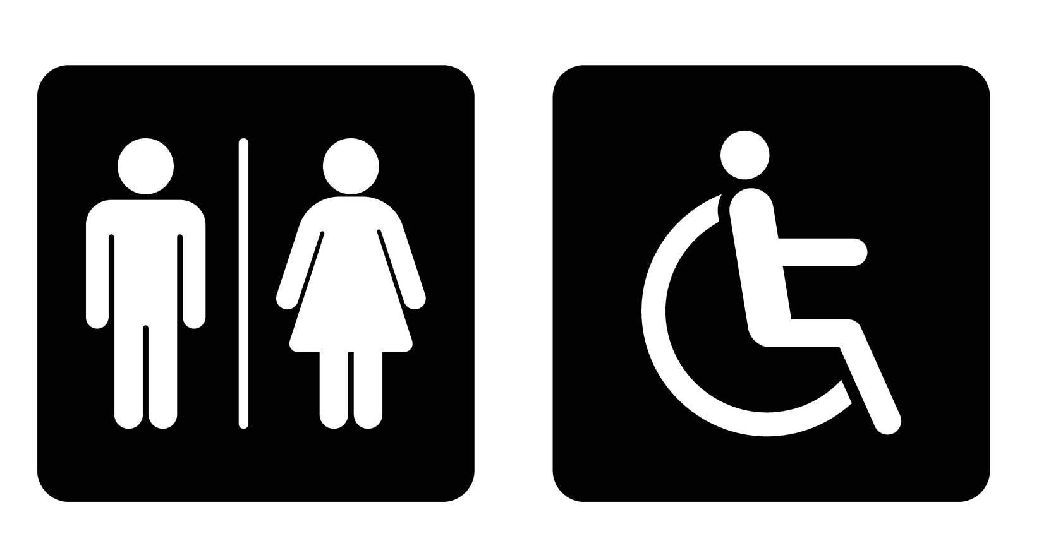

What would you do if some of the food you were working with fell on the floor?

Stop what you are doing and put everything down. Pick up what has fallen on the floor and throw it in the bin. Tell the teacher what has happened. You may need to wipe the floor with some kitchen towel. Wash and dry your hands properly.

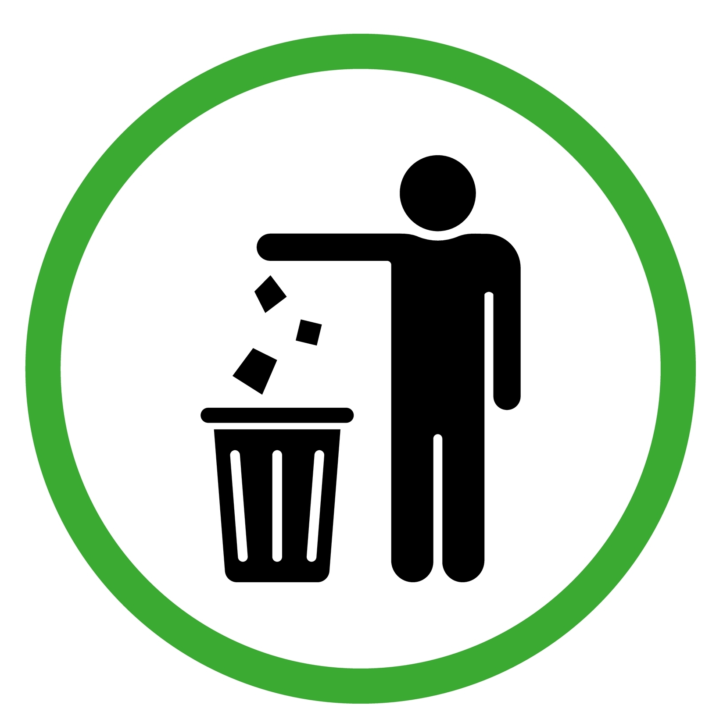

What if something runny got spilt on the floor?

Stop what you are doing and tell the teacher what has happened. You may need to wipe the floor with some kitchen towel. If you do wipe the floor you need wash and dry your hands properly before you go back to your food work.



What would you do if…

Think of a situation that could happen when you are cooking and talk about what would be the best thing to do.

